**Worksheet 4: Version Control (Python)**

Thi Van Anh DUONG Student ID: 90023112

Diploma of Information Technology, Curtin College

ISEN1000: Introduction to Software Engineering

Coordinator: Khurram Hameed

21 March 2022

## **Student Declaration of Originality**

|  |  |
| --- | --- |
|  | This assignment is my own original work, and no part has been copied from another student’s work or source, except where it is clearly attributed. |
|  | All facts/ideas/claims are from academic sources are paraphrased and cited/referenced correctly. |
|  | I have not previously submitted this work in any form for THIS or for any other unit; or published it elsewhere before. |
|  | No part of this work has been written for me by another person. |
|  | I recognise that should this declaration be found to be false, disciplinary action could be taken and penalties imposed in accordance with Curtin College policy. |

**Electronic Submission:**

|  |  |
| --- | --- |
|  | I accept that it is my responsibility to check that the submitted file is the correct file, is readable and has not been corrupted. |
|  | I acknowledge that a submitted file that is unable to be read cannot be marked and will be treated as a non-submission. |
|  | I hold a copy of this work if the original is damaged, and will retain a copy of the Turnitin receipt as evidence of submission. |

**Enter user name and email address.**

**Make a copy Maze.py**

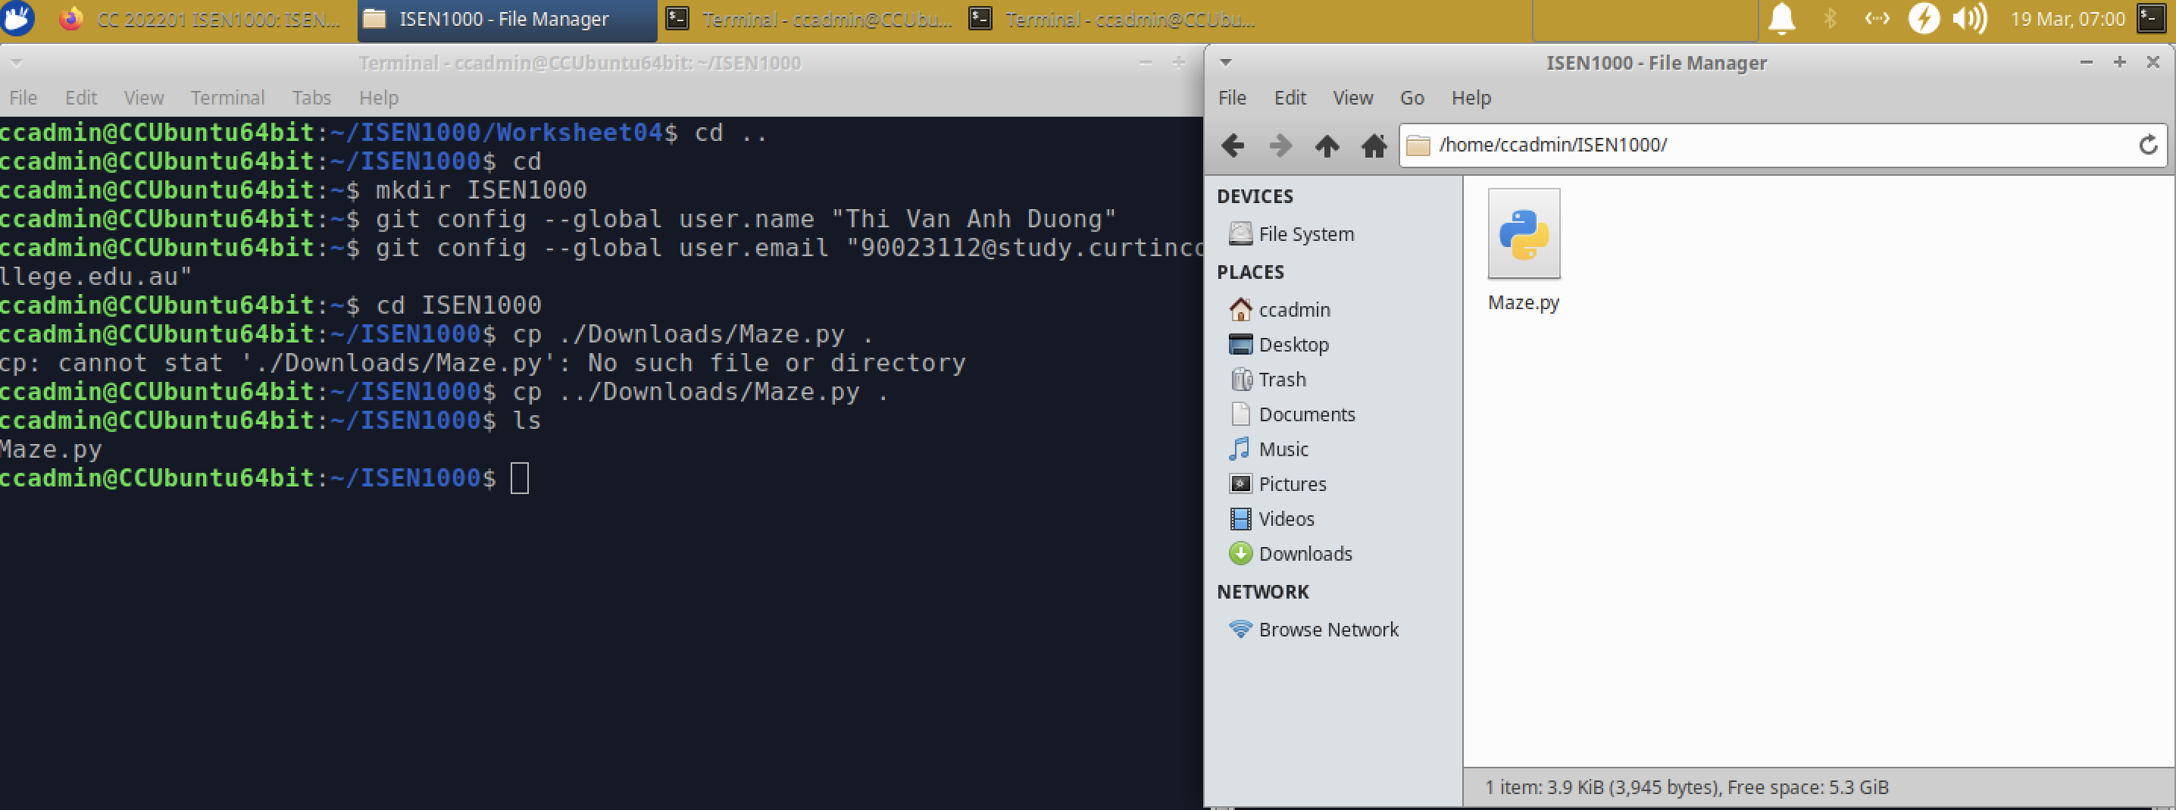

1. **Commits**
2. Create and initialise a local Git repository

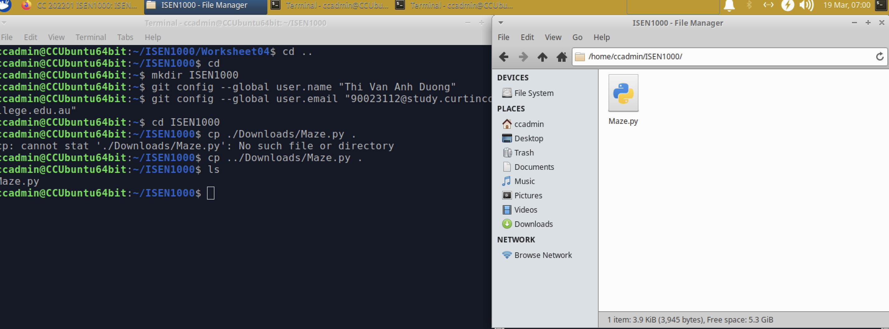

1. Copy Maze.py and make the first commit

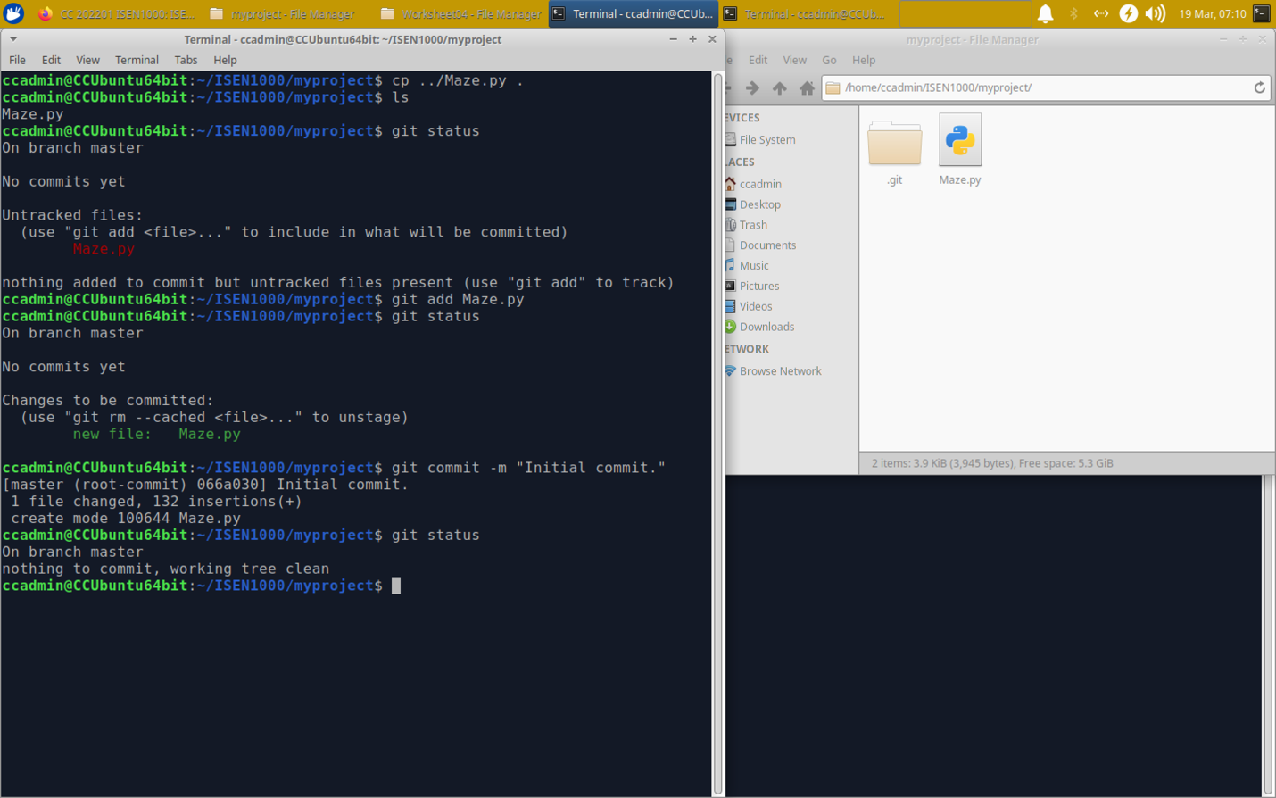

*Answer question*: *“git add”* here is the command that add a change in the working directory to the staging area. It also helps us tell *git* that we want to include the update to a specific file in the next commit.

(c). Modify Maze.py

(i) – Create GridViewer.py and copy code

(ii) – Copy and paste the viewing code

(iii) – Replace GridViewer.py

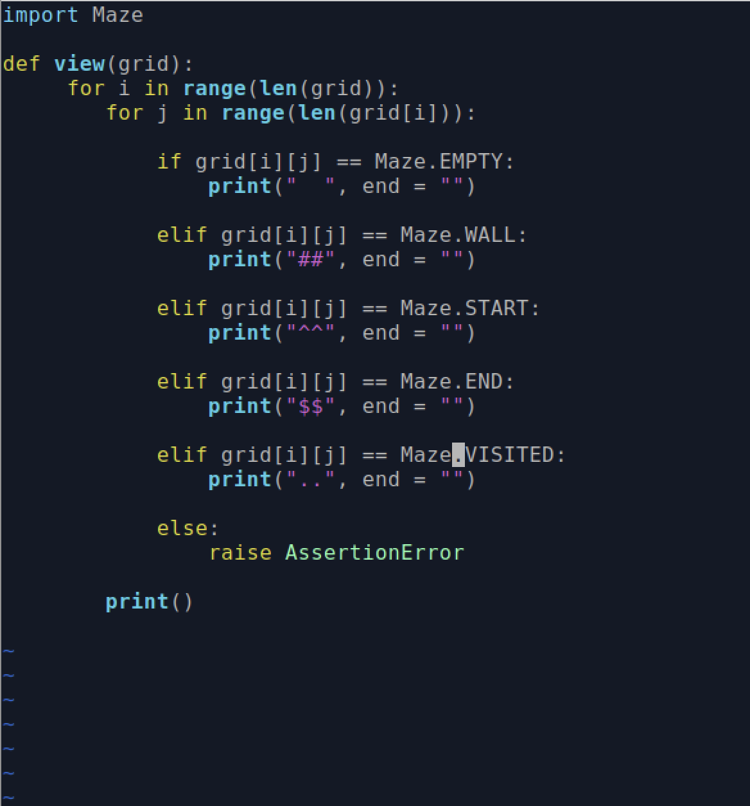

(iv) – Fix Maze.py

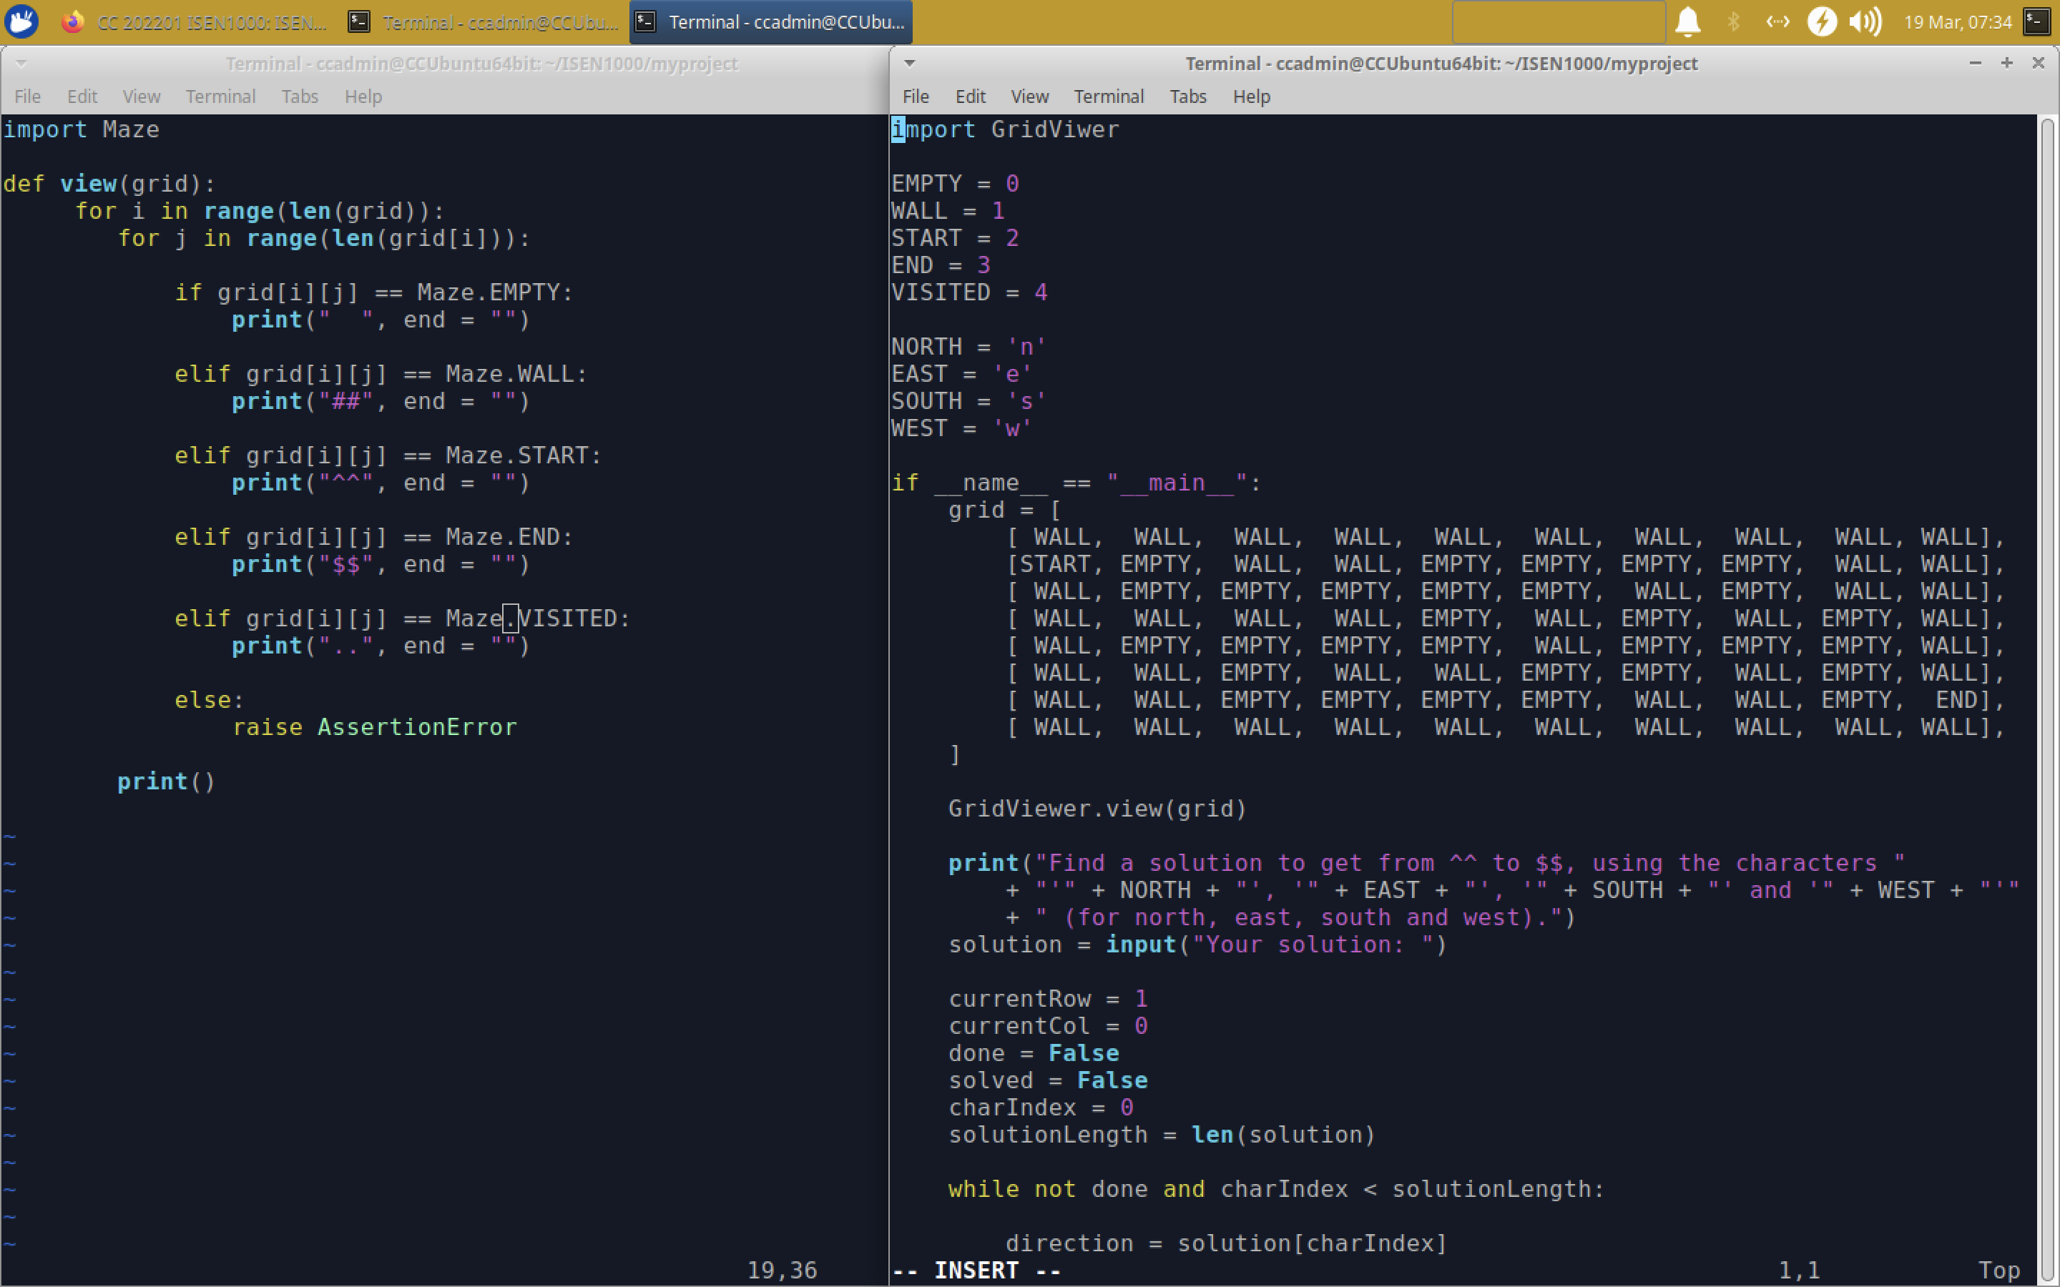

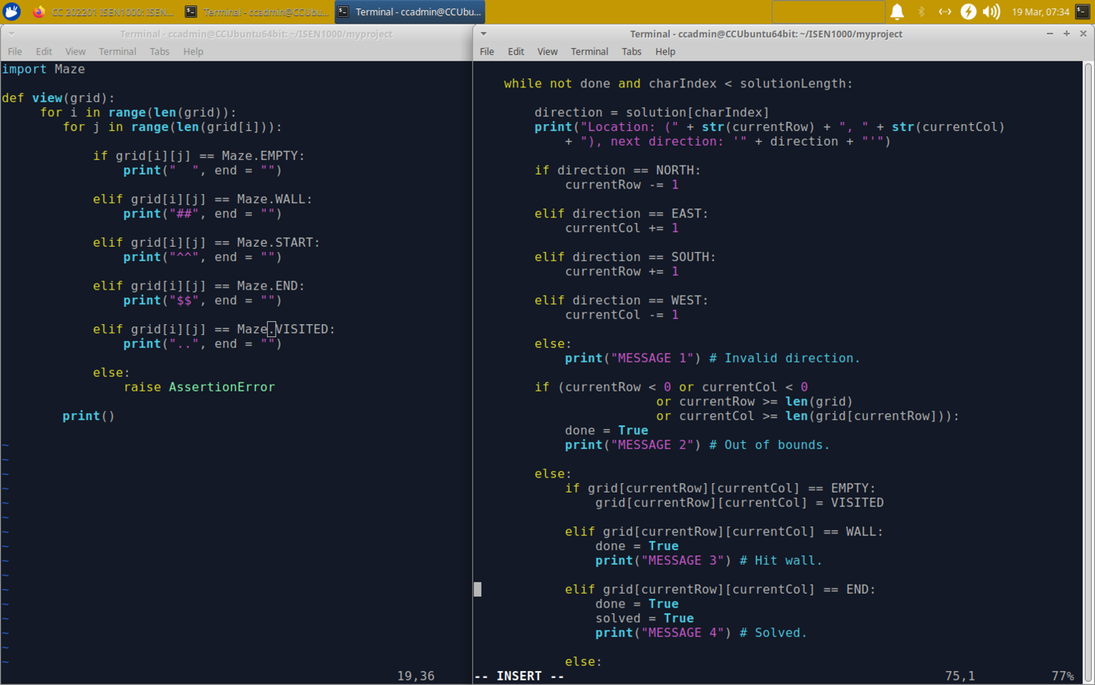

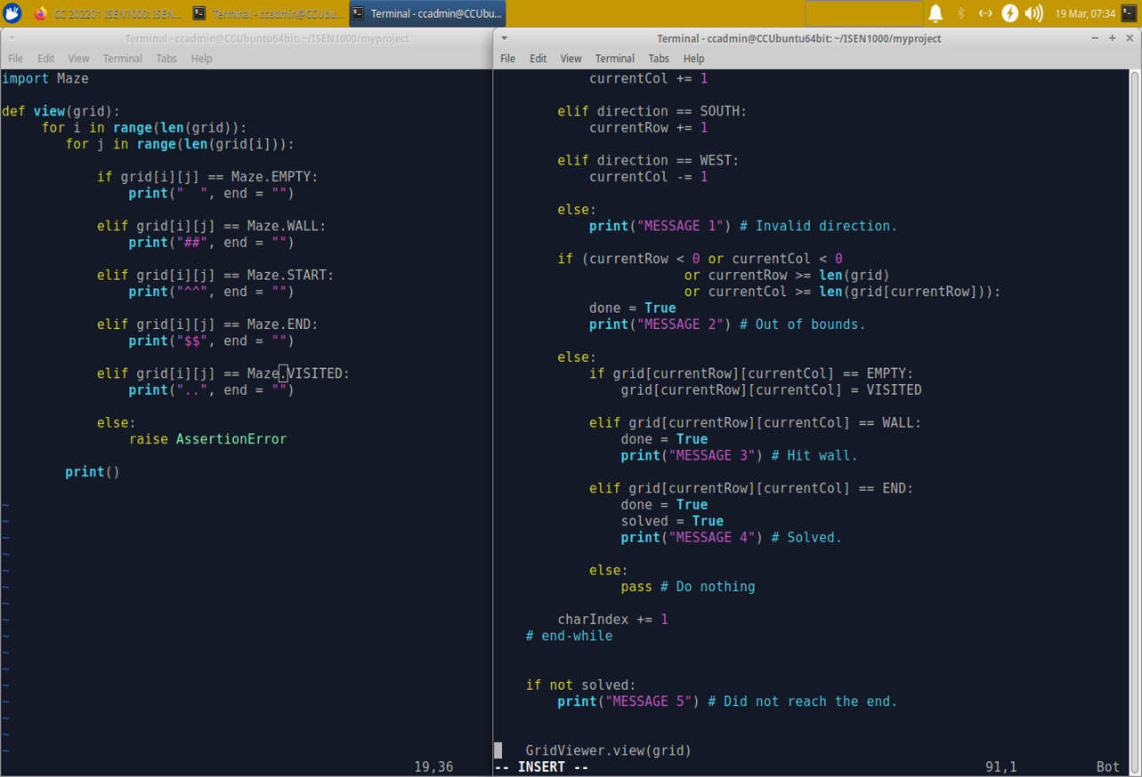

(v) – Examine changes , (vi) -Stage both files and make a commit.

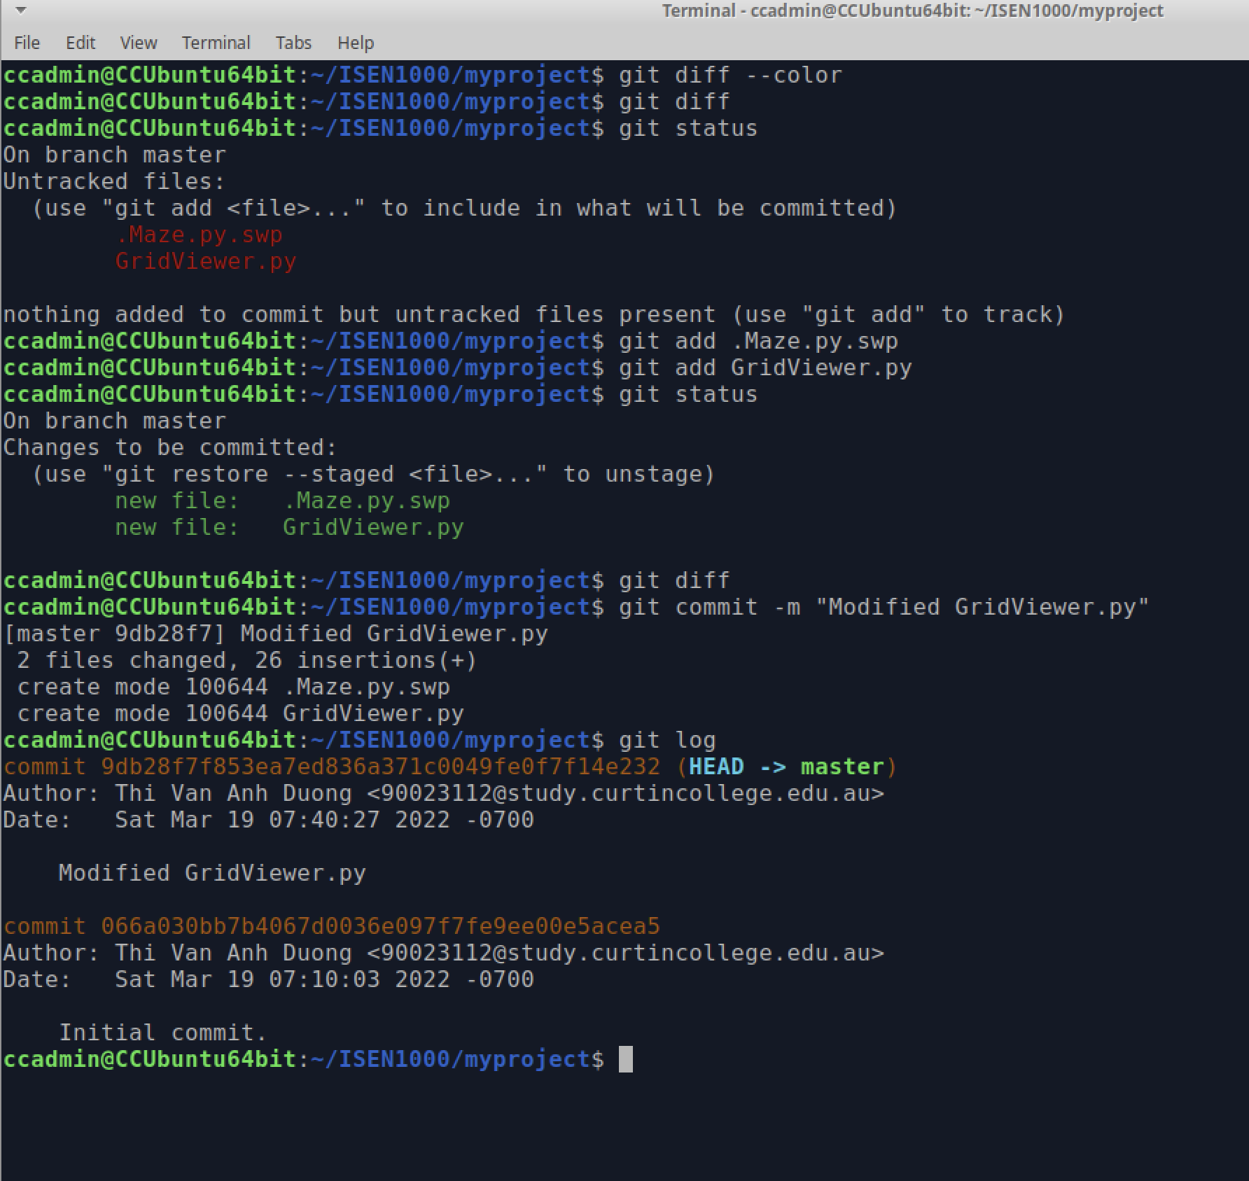

(vii) Check *git status* to ensure errors, (viii) See 2 previous commits

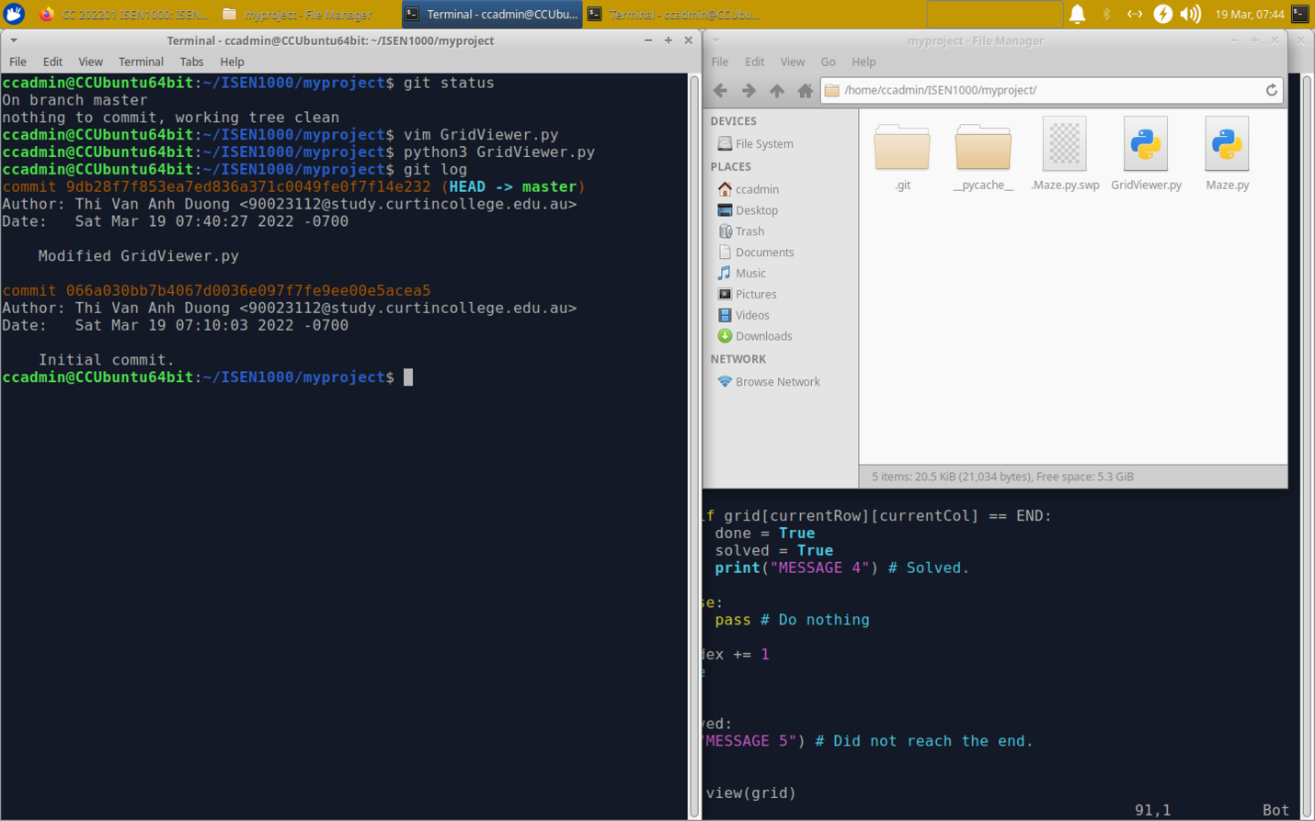

*Answer question*: Because we changed code in both files, so we have to stage both of them to update the changes to *git*

1. **Deletion and Renaming**

Escape INSERT mode of vim text and use this command to rename GridViewer.py to Viewer.py: :w Viewer.py

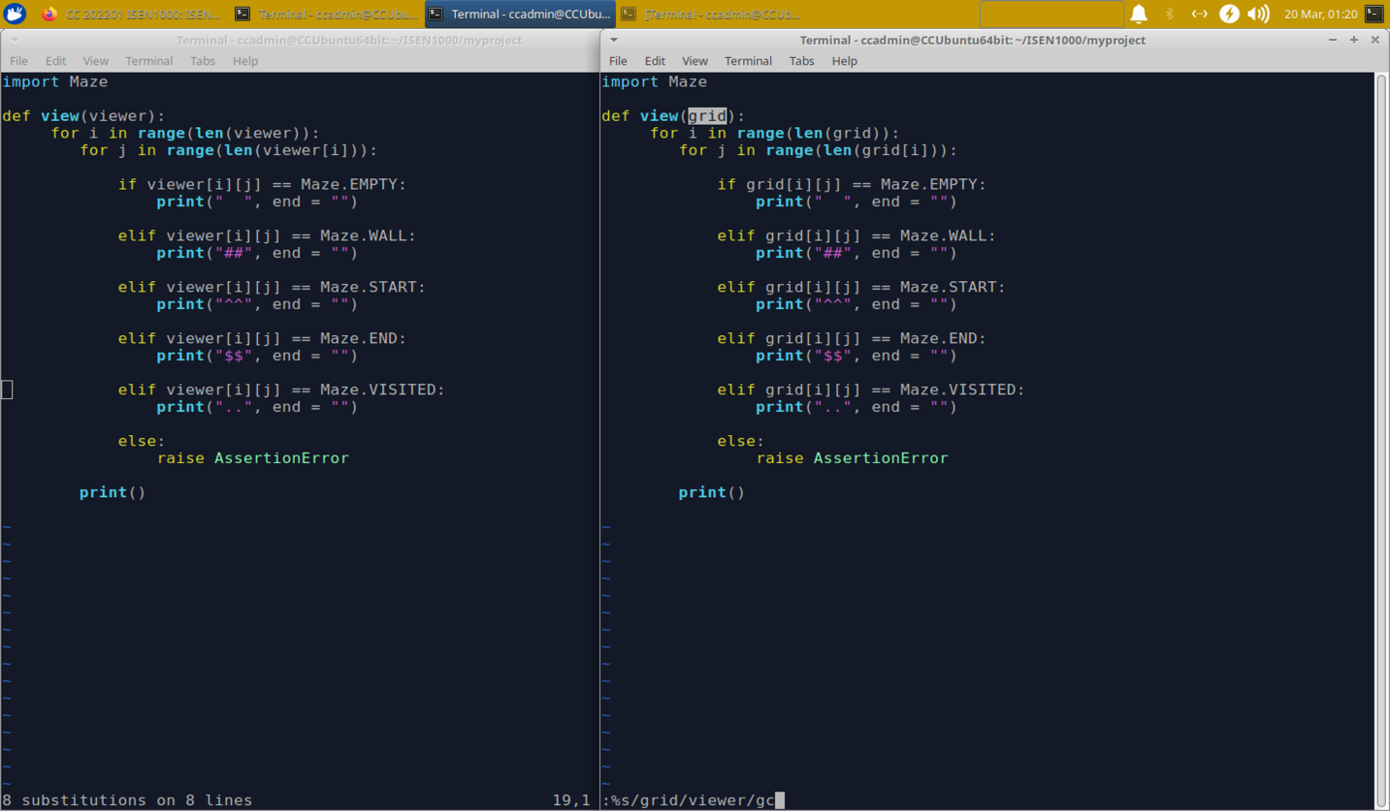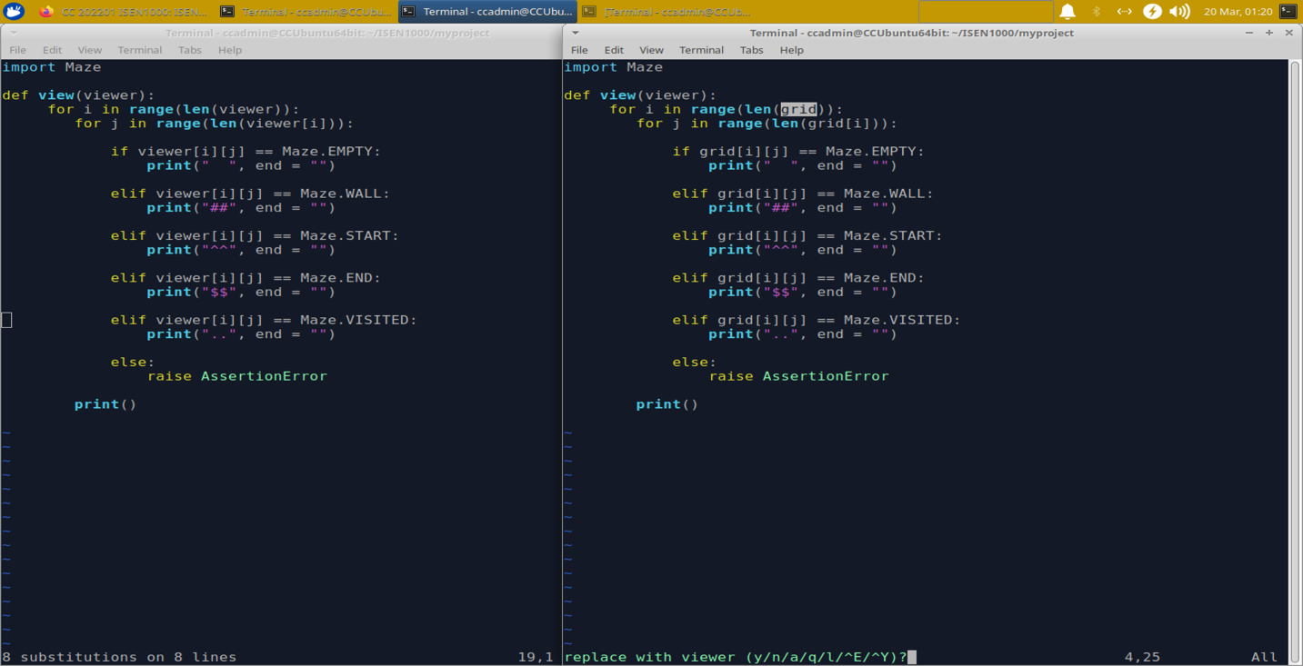

Run “git status and observe”:

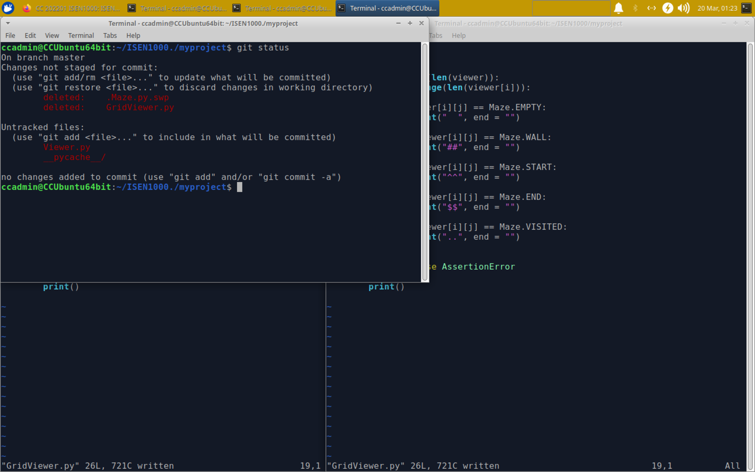

Stage Viewer.py and Maze.py

Stage the removal

Run “git status” again and make a commit

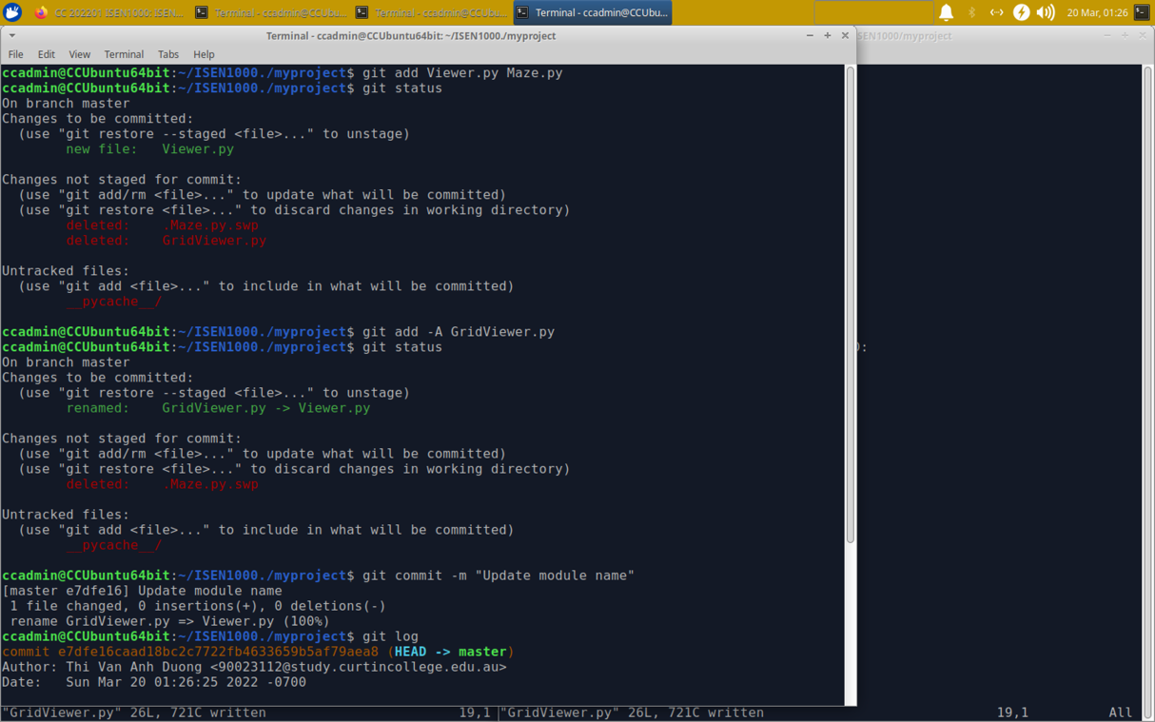

1. **Branching and Merging**
2. Create two new branches called “updating_maze” and “updating_messages” :

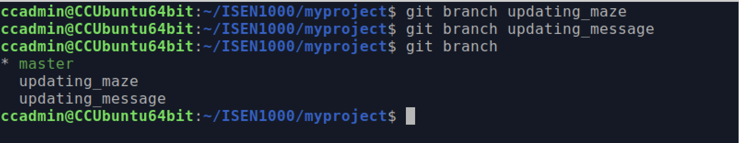

1. Checkout “updating_maze”

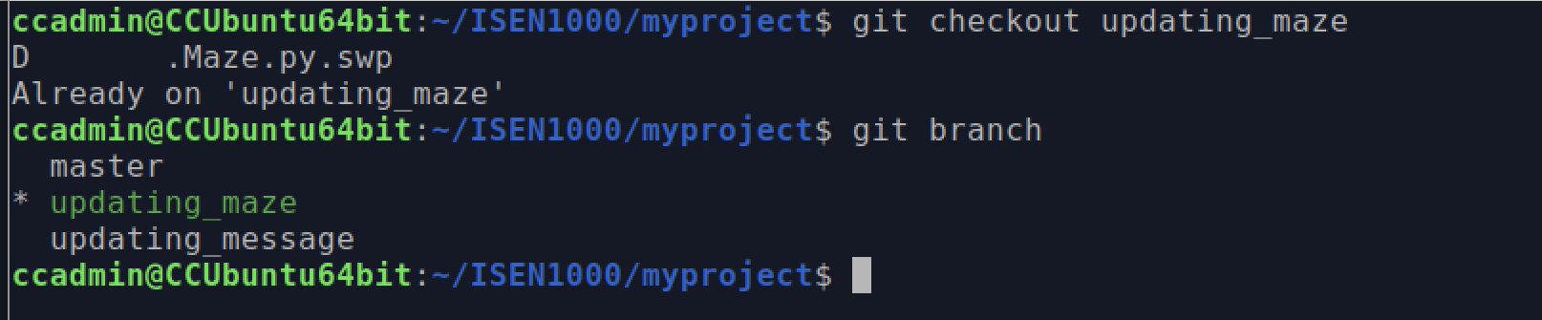

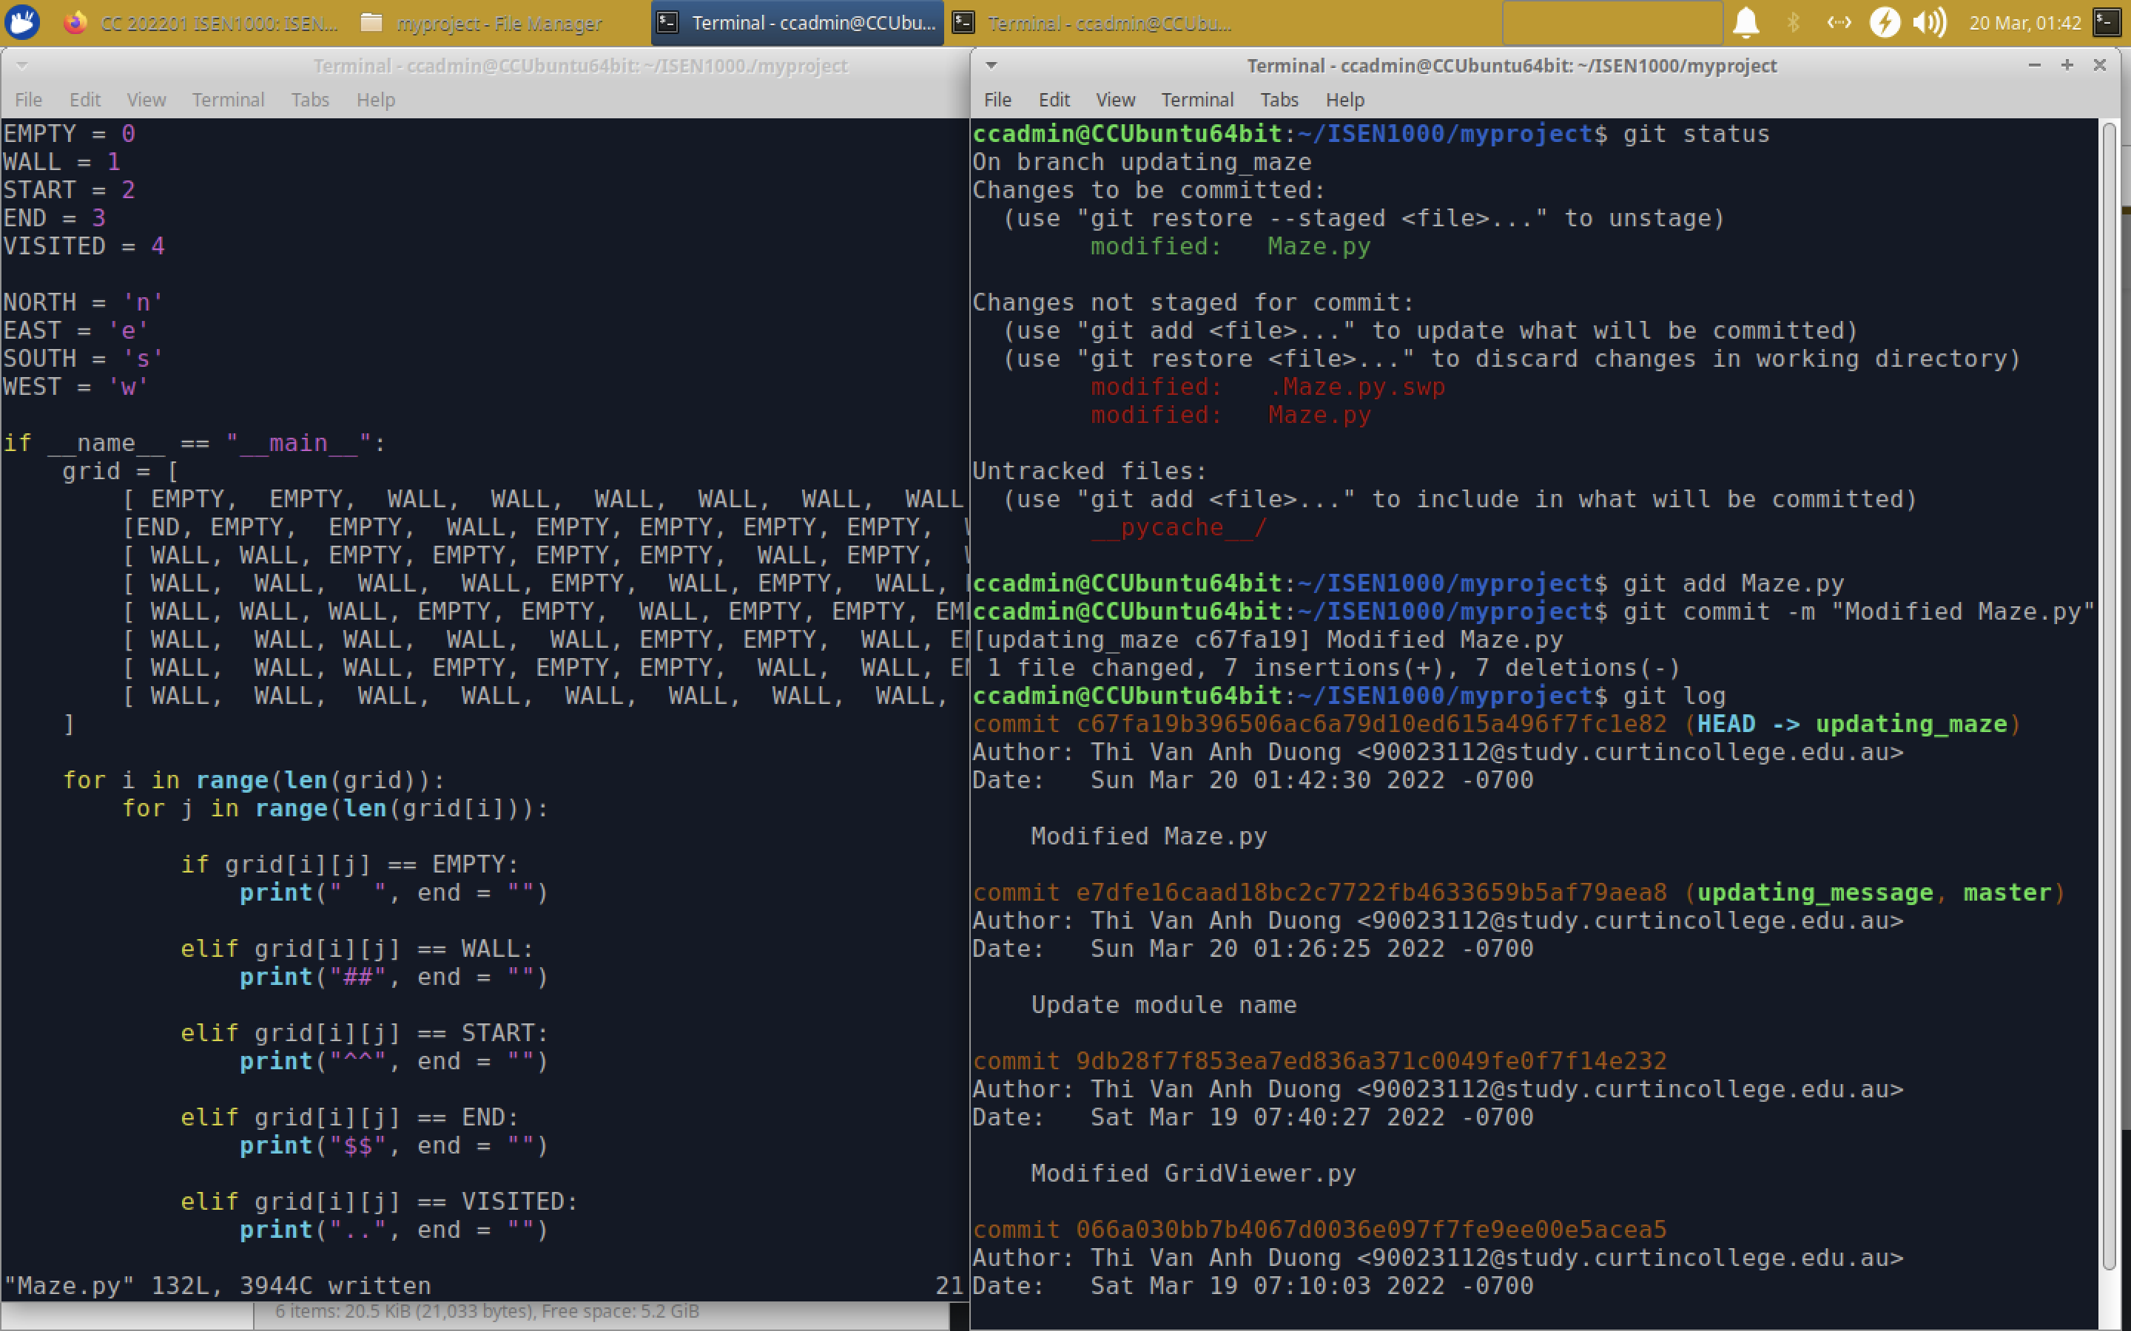

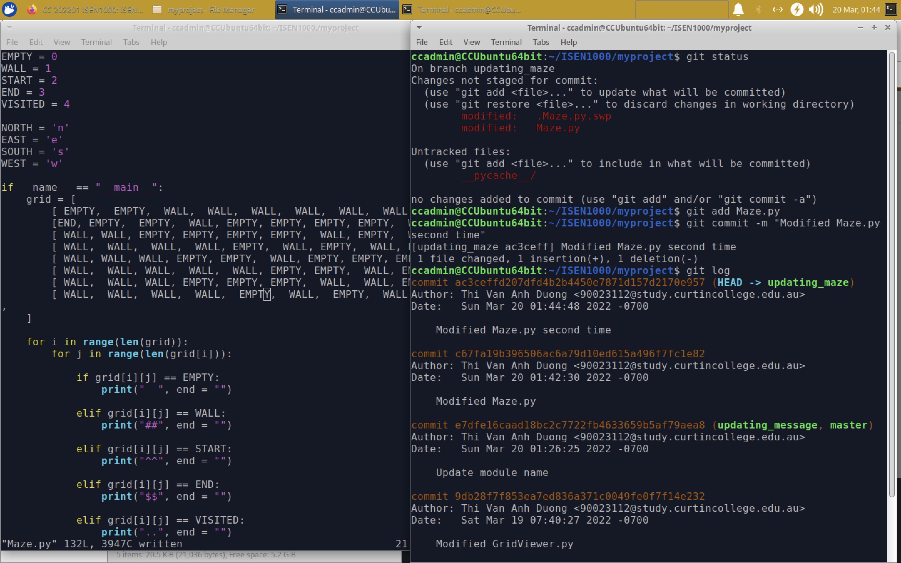

(c ) Checkout “updating_message”

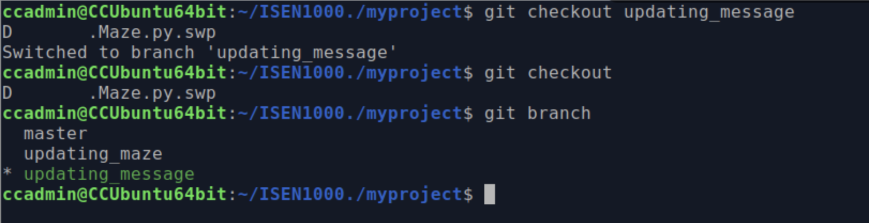

*Can I have a question ? – Why the line “D .Maze.py.swp” appears when I checkout a branch ? I have definitely closed all file and vim text before creating new branch.*

The code is still the same!

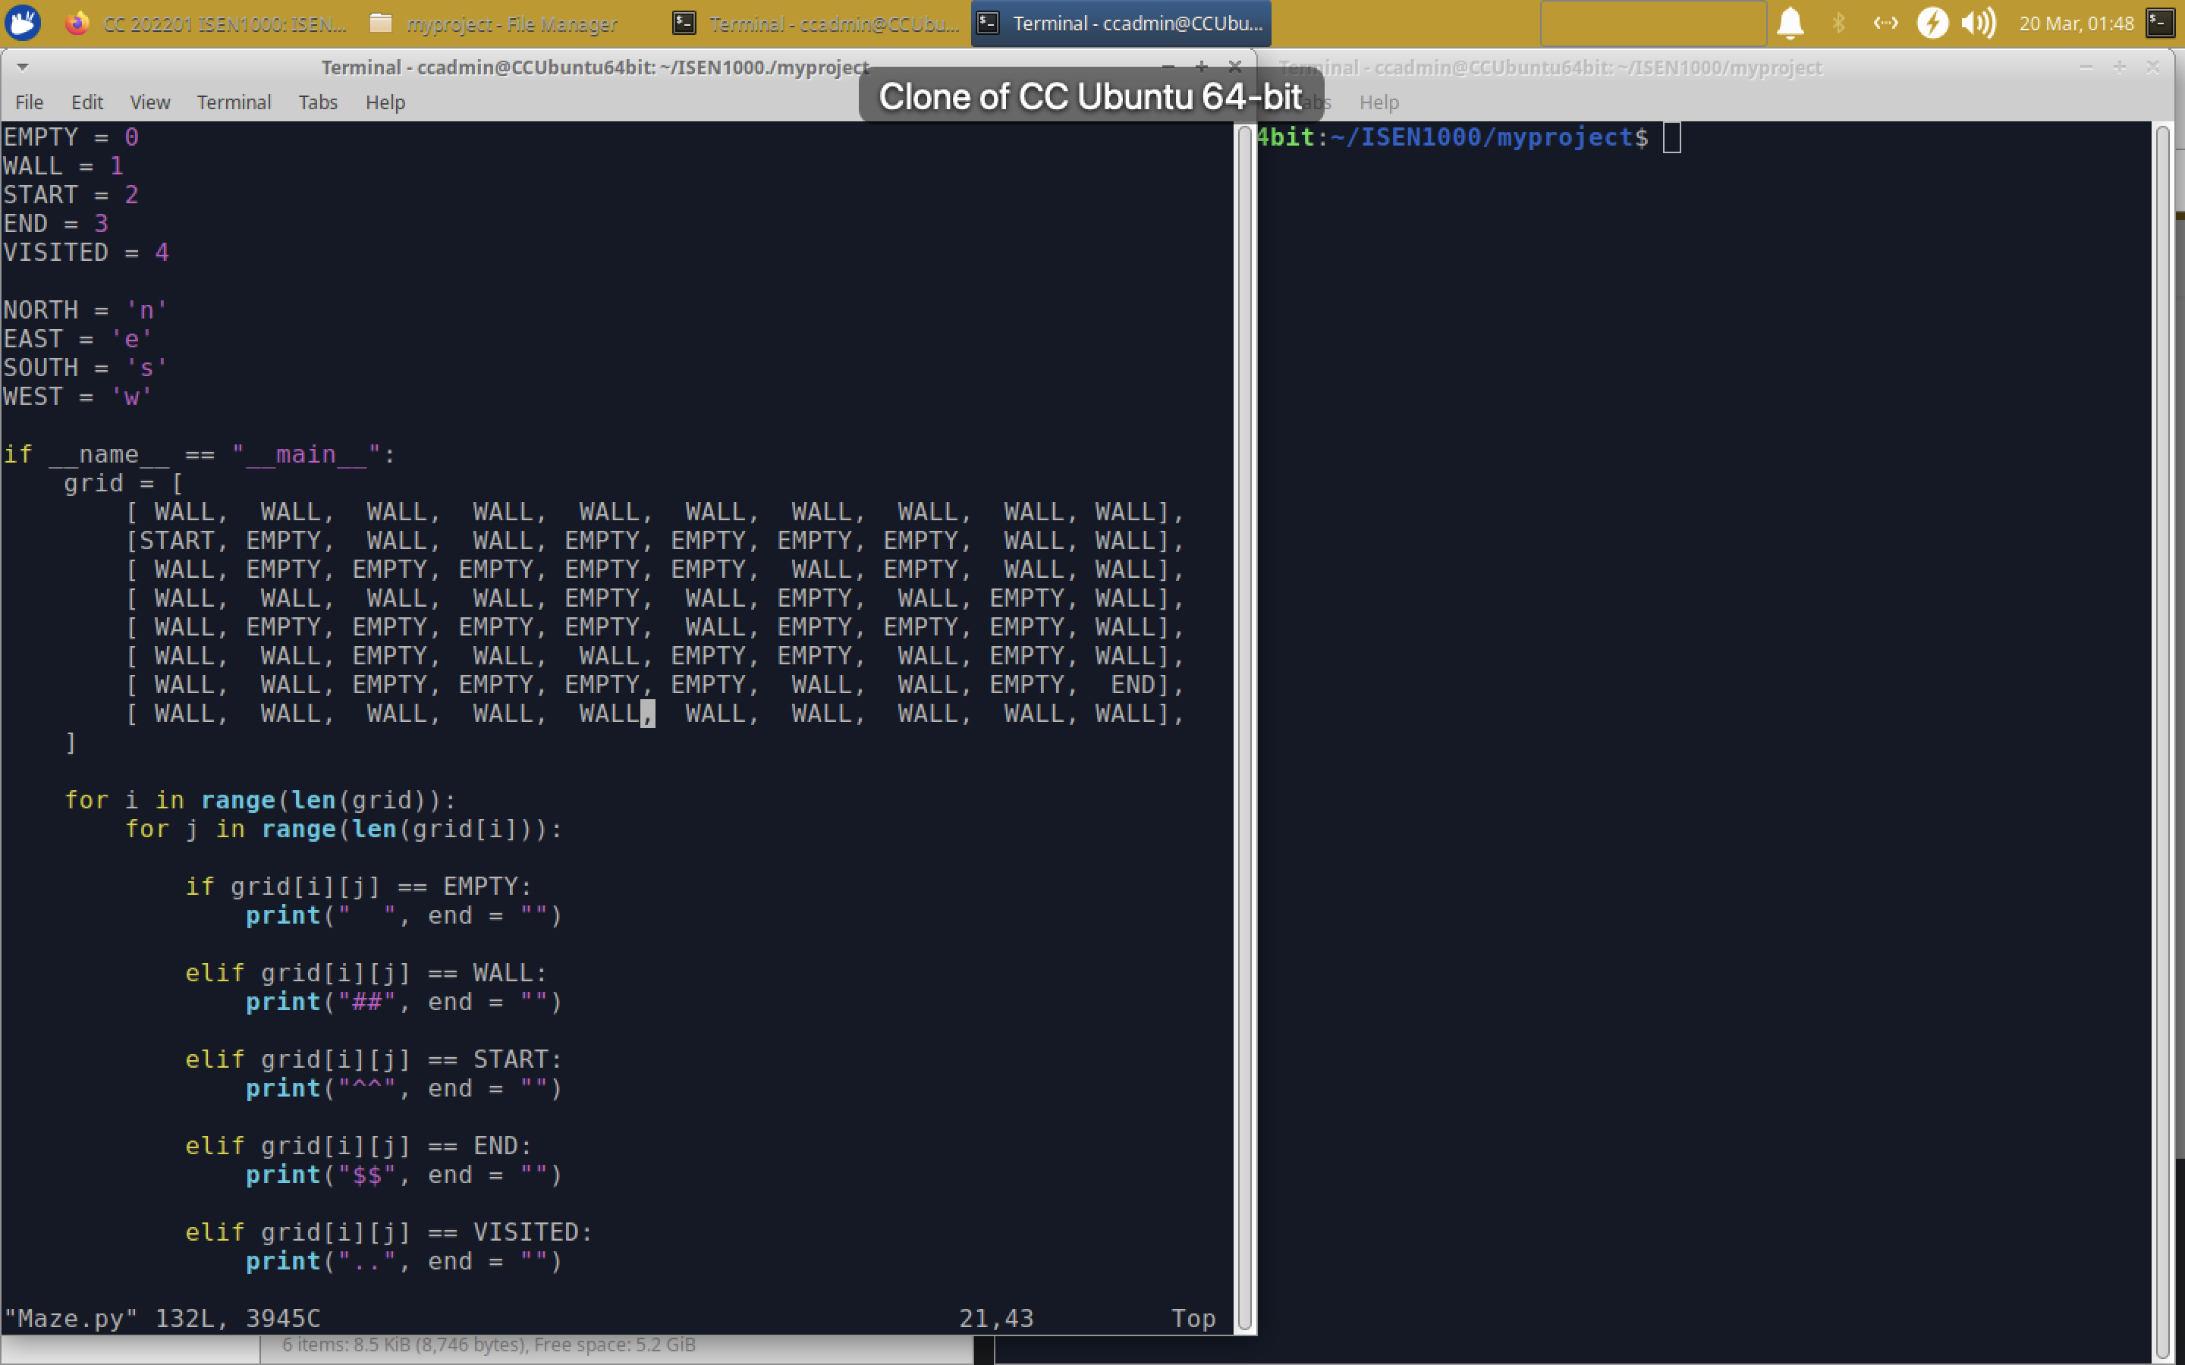

Fix message 1-3

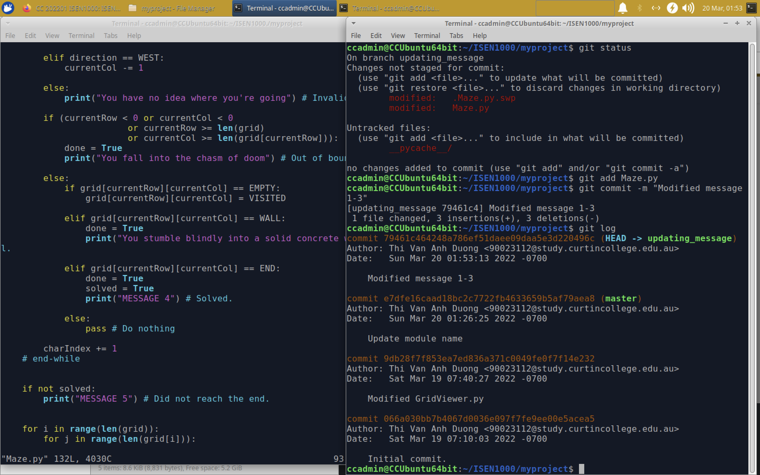

Fix message 4-5

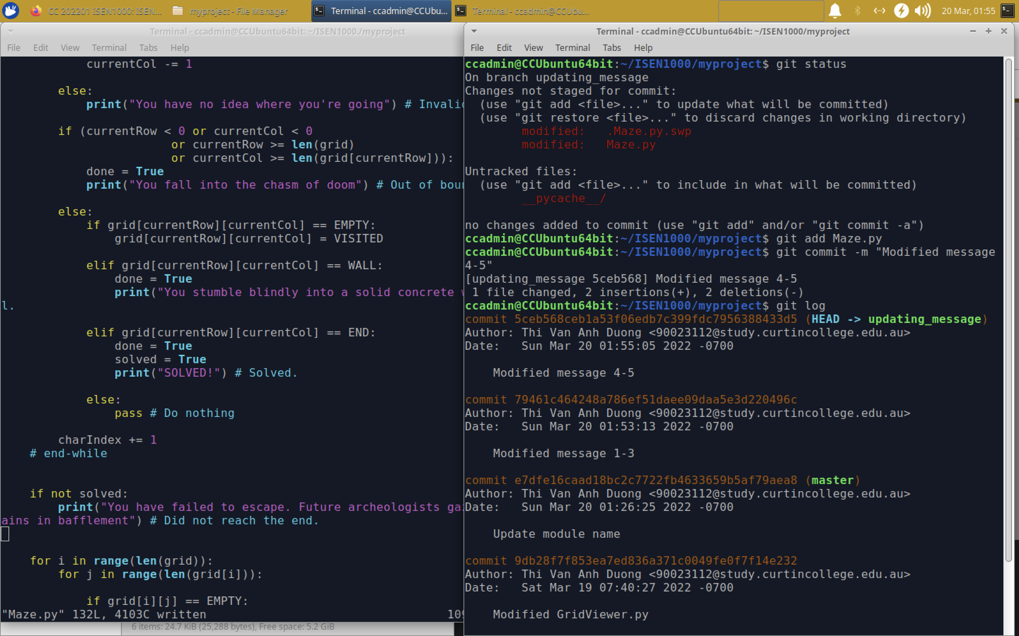

(d)

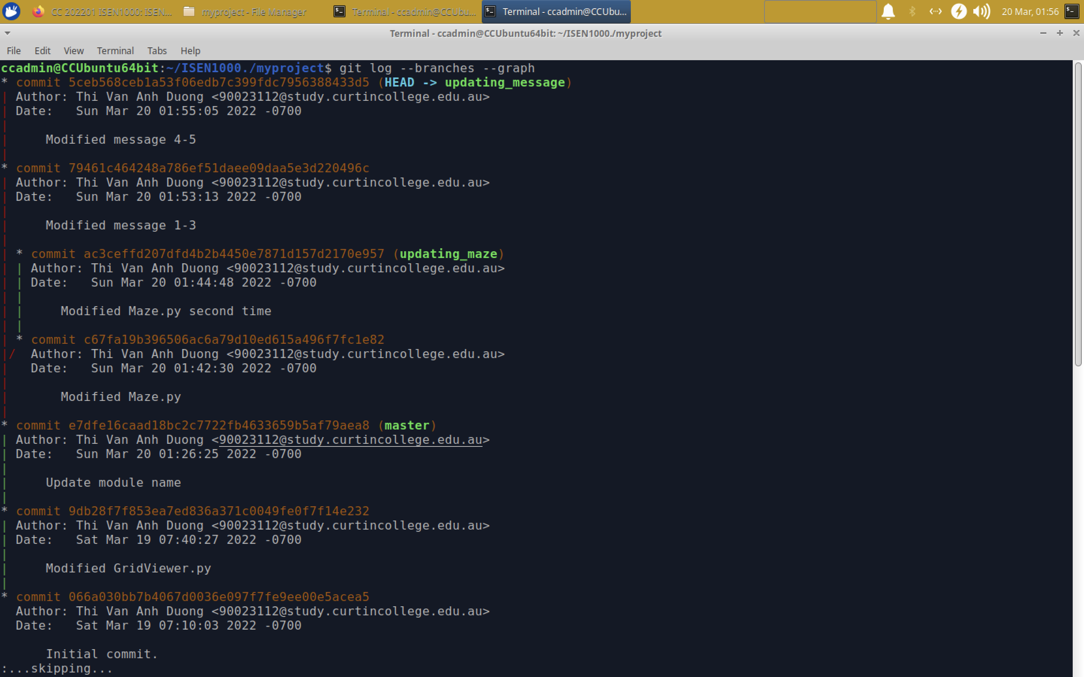

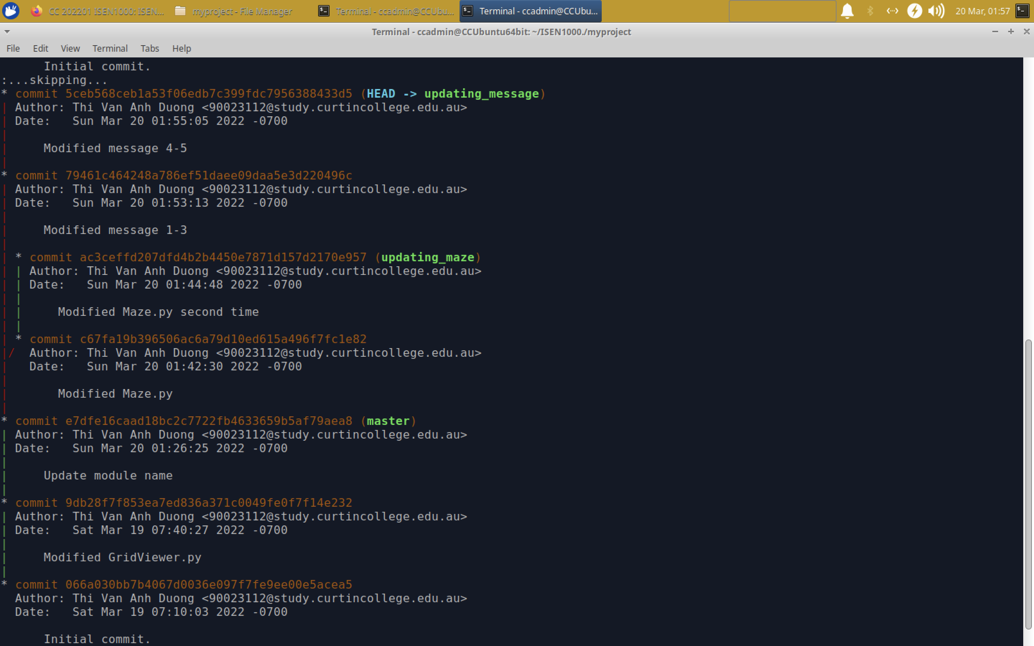

(e) Merge time!

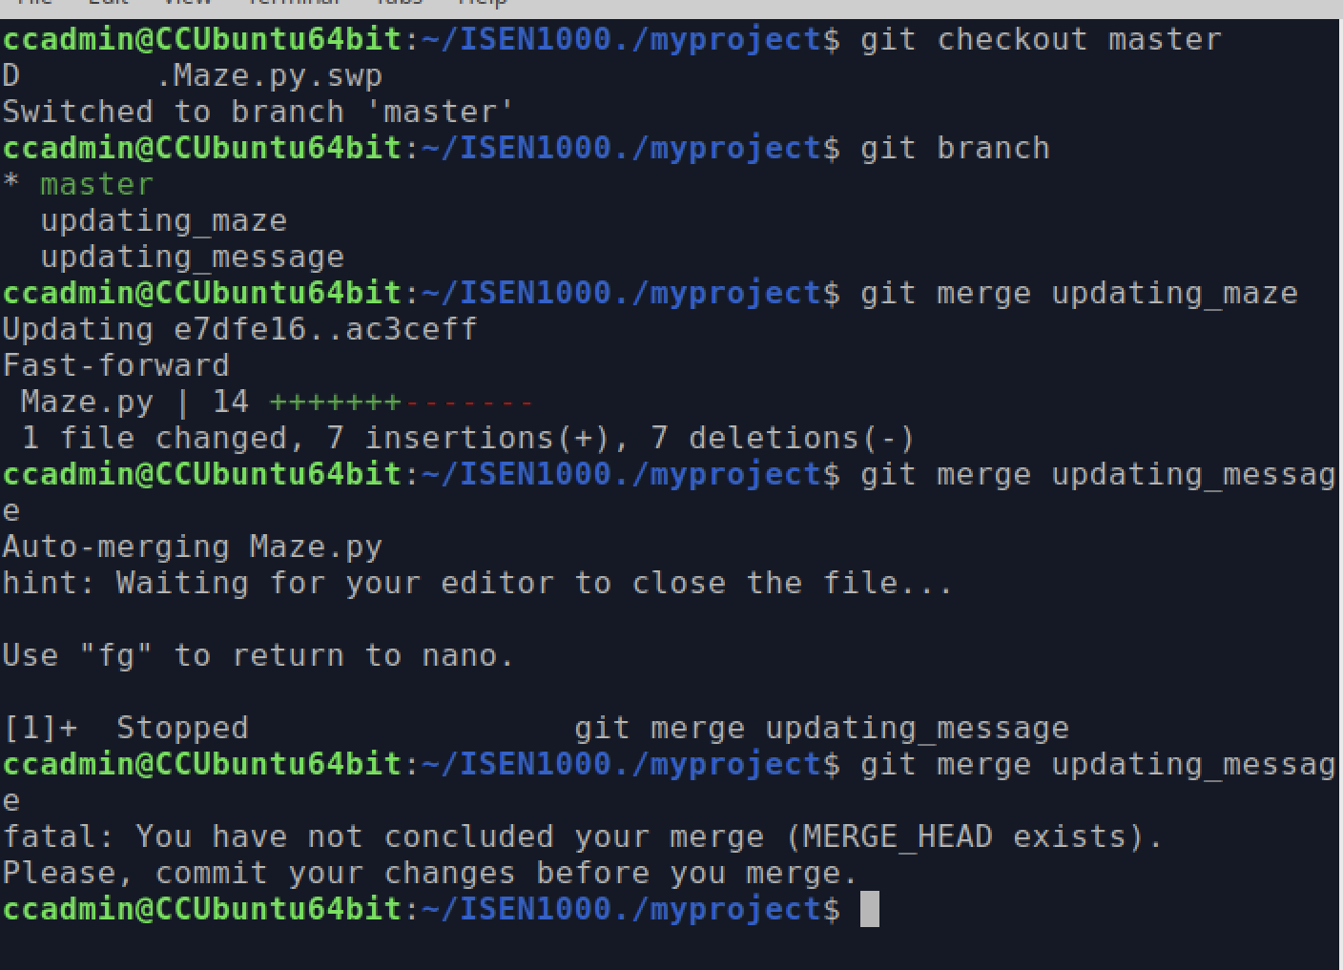

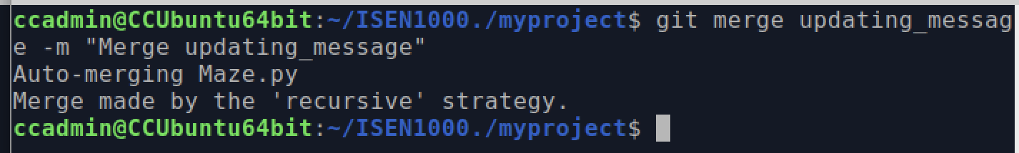

Amazing! Maze.py contains all of my changes in the two separate branches

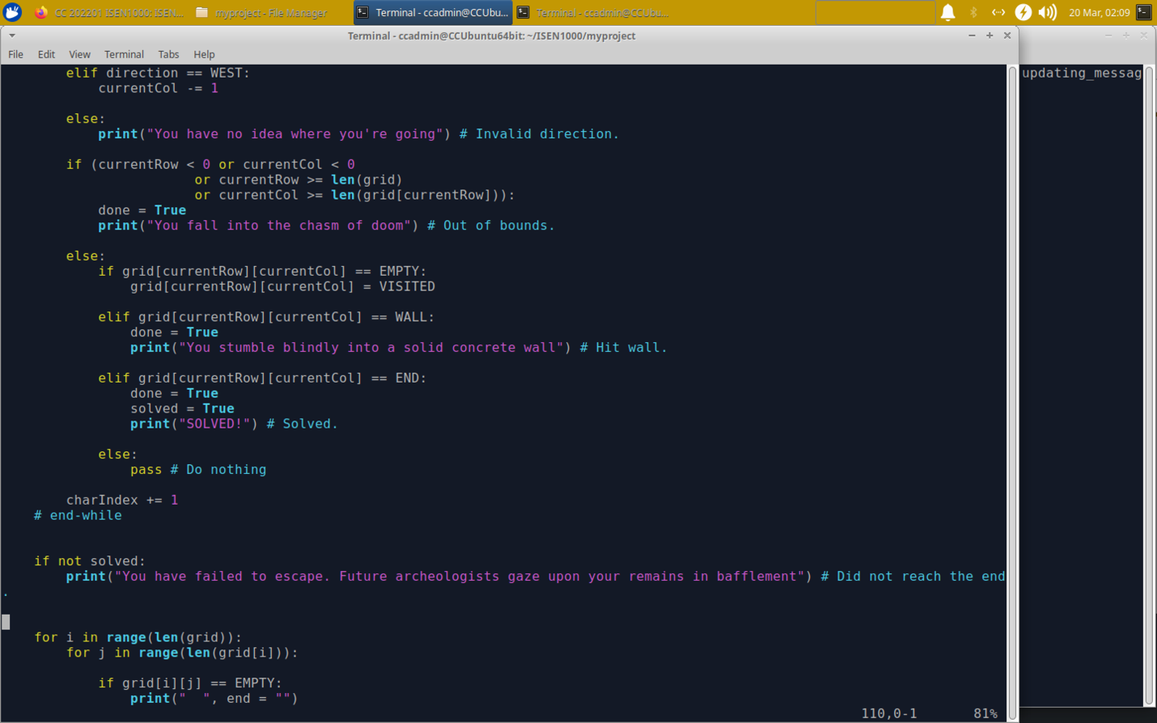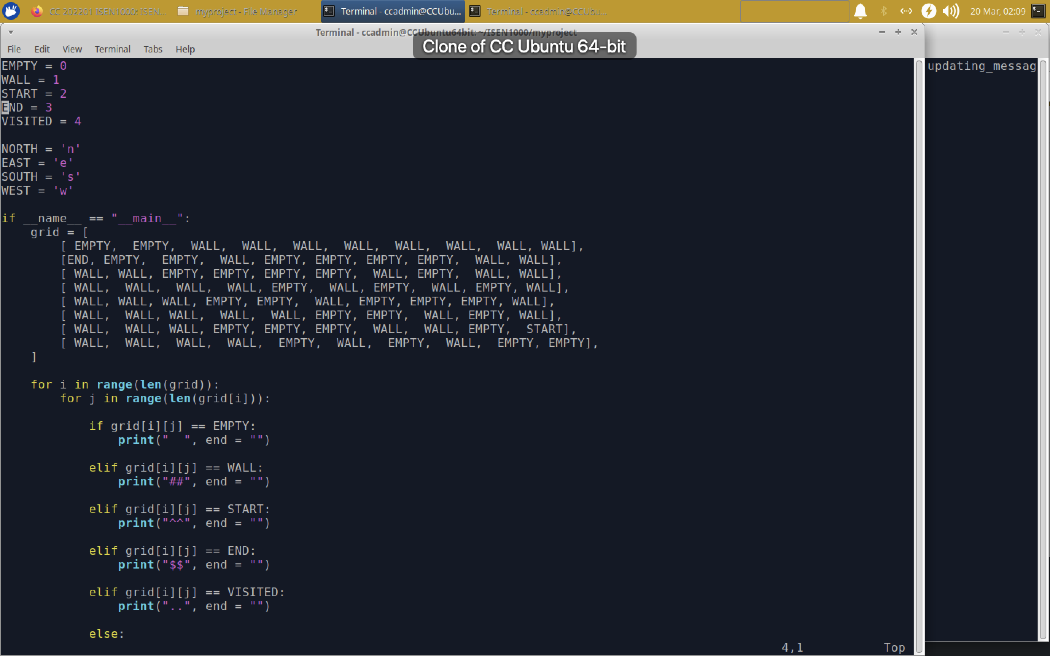

See the merge commit and *git log* :

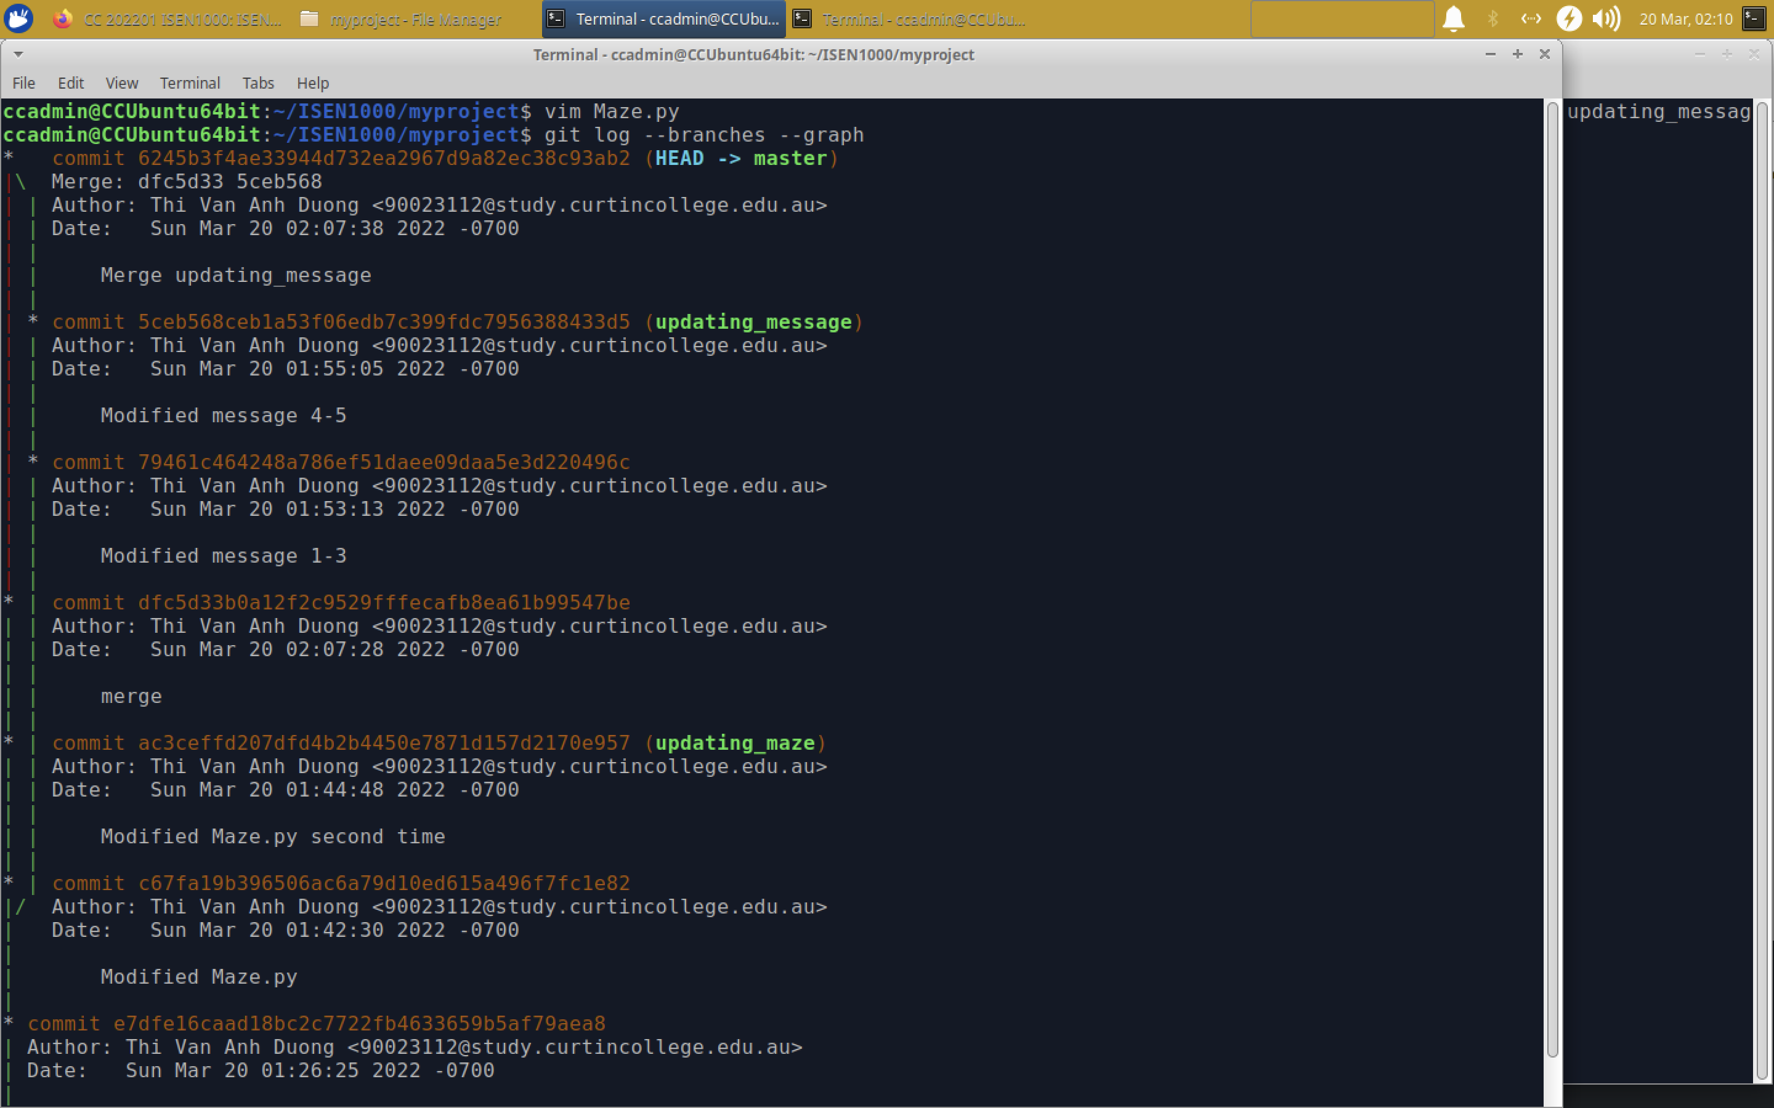

(f) Delete two new branches

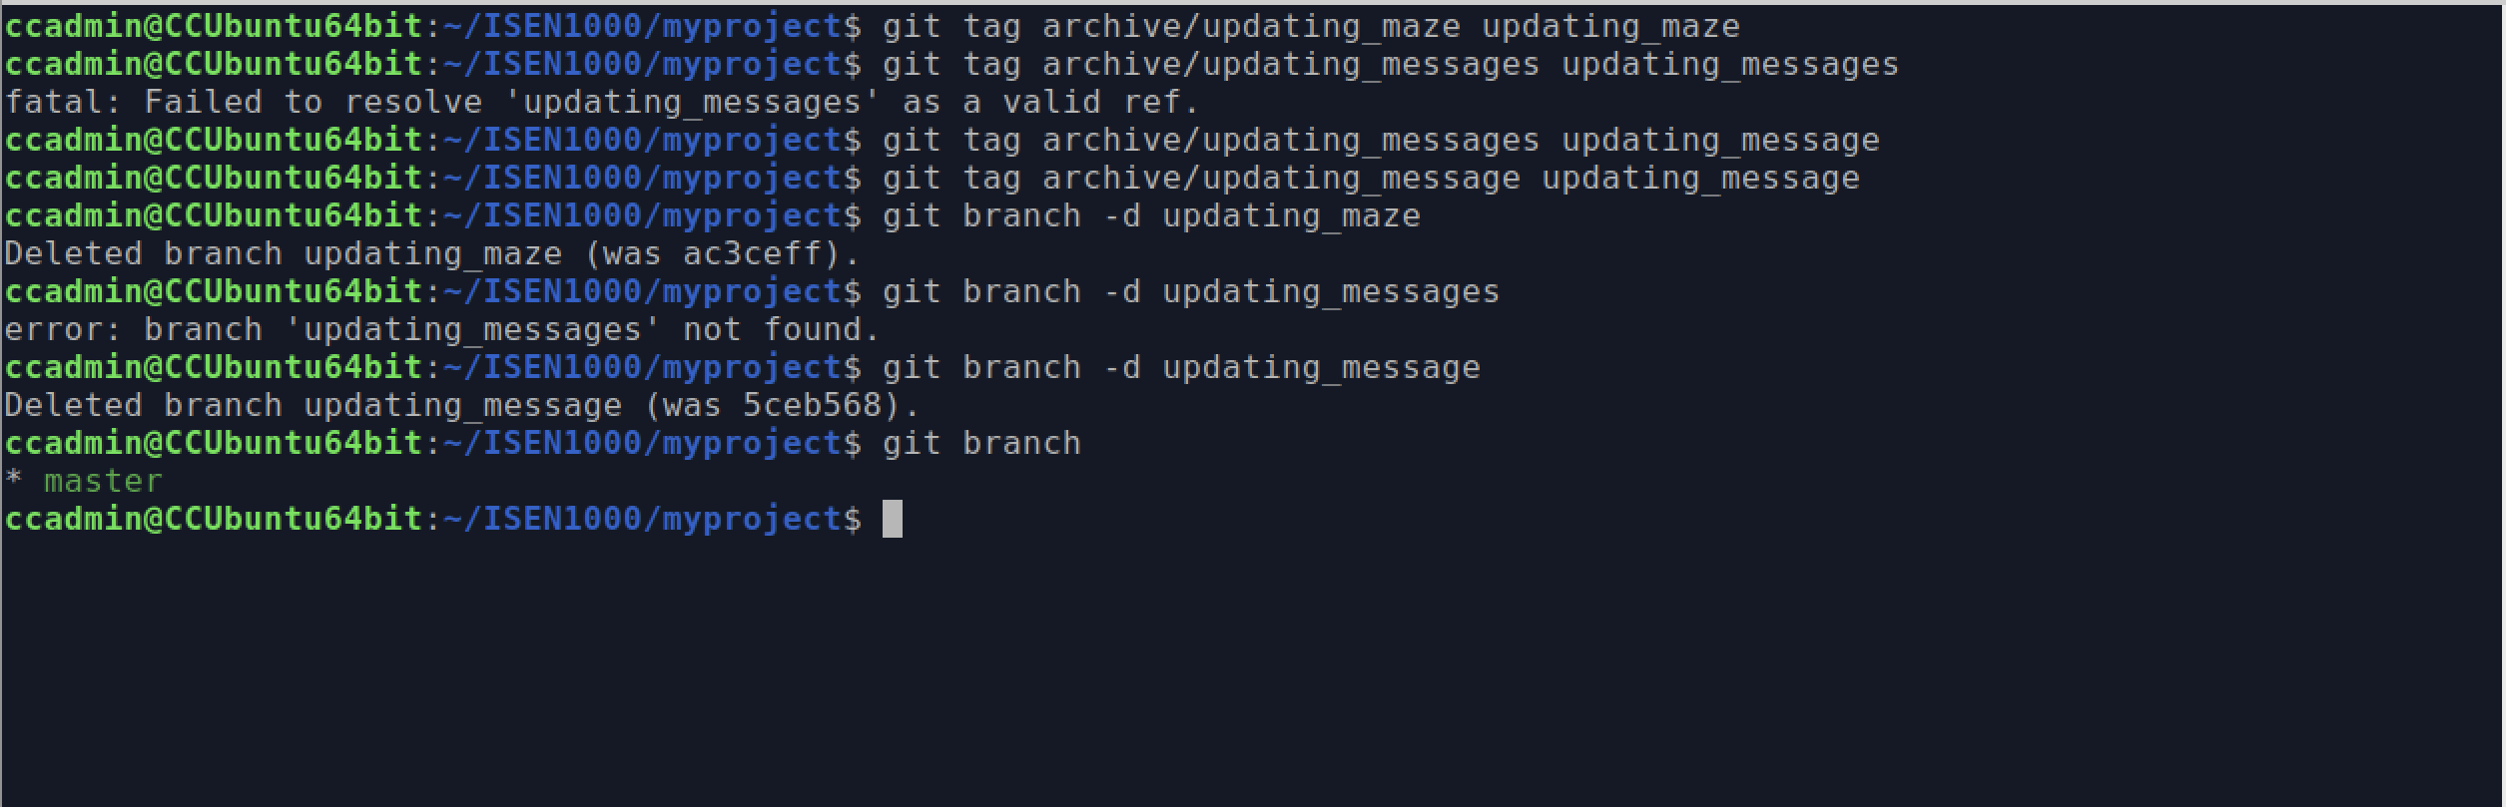

1. **Merge Conflicts**
2. Create another two branches

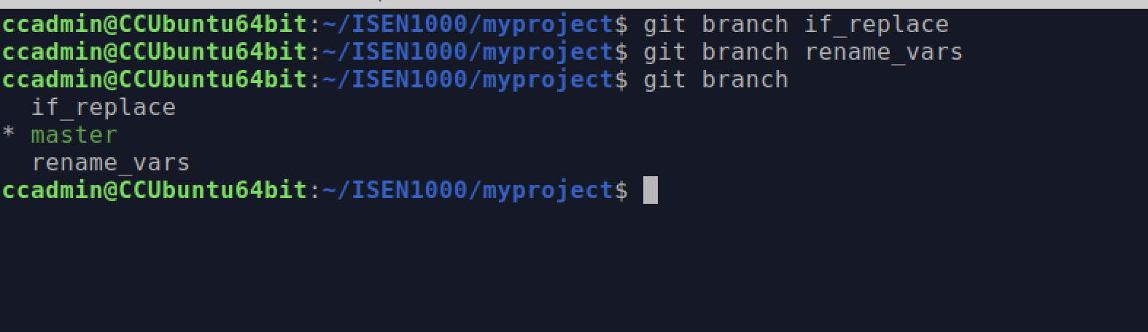

1. Switch to if_replace and modify code

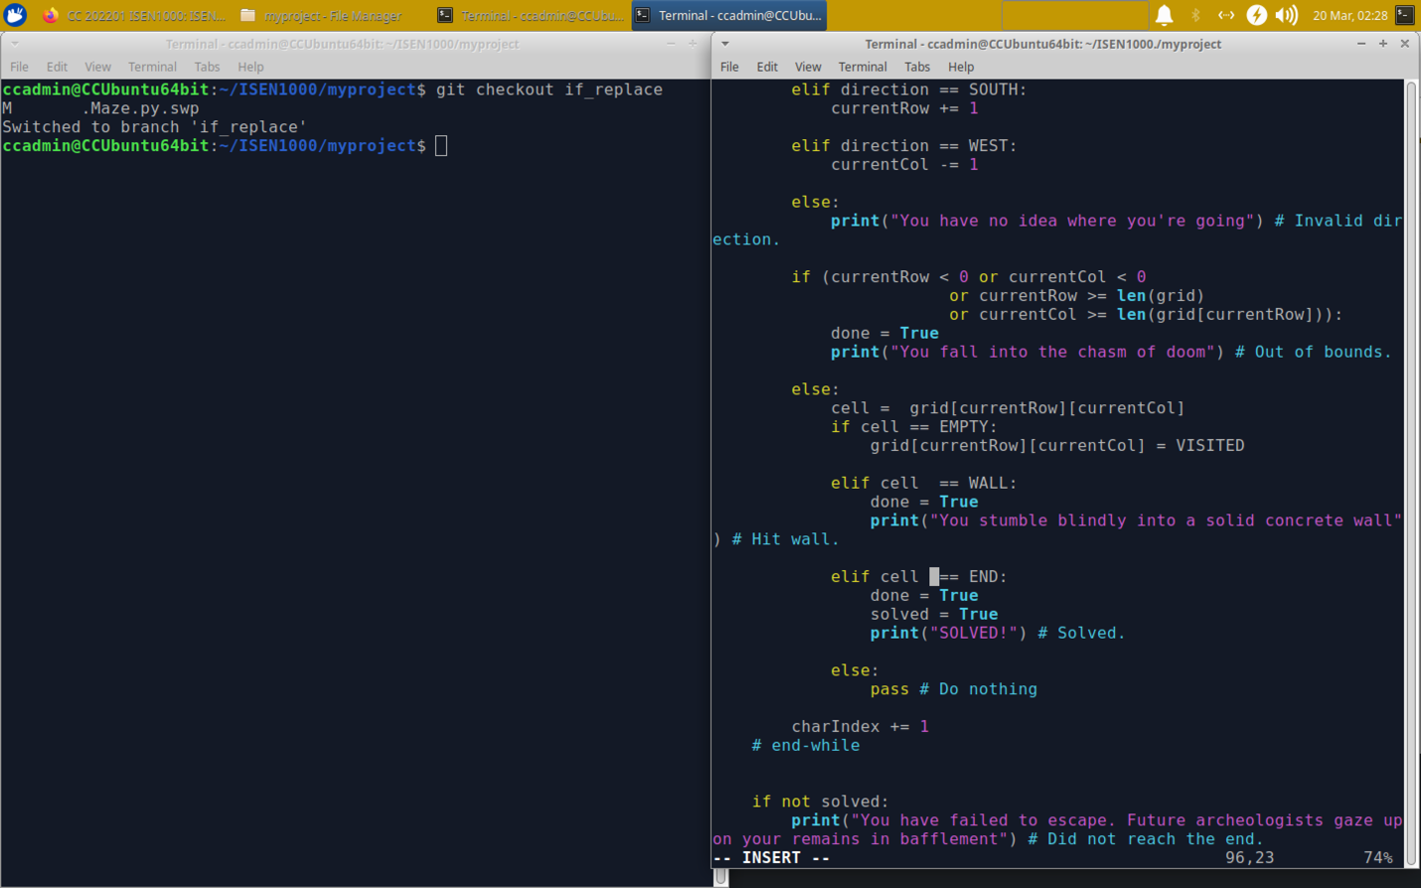

Stage and commit my changes:

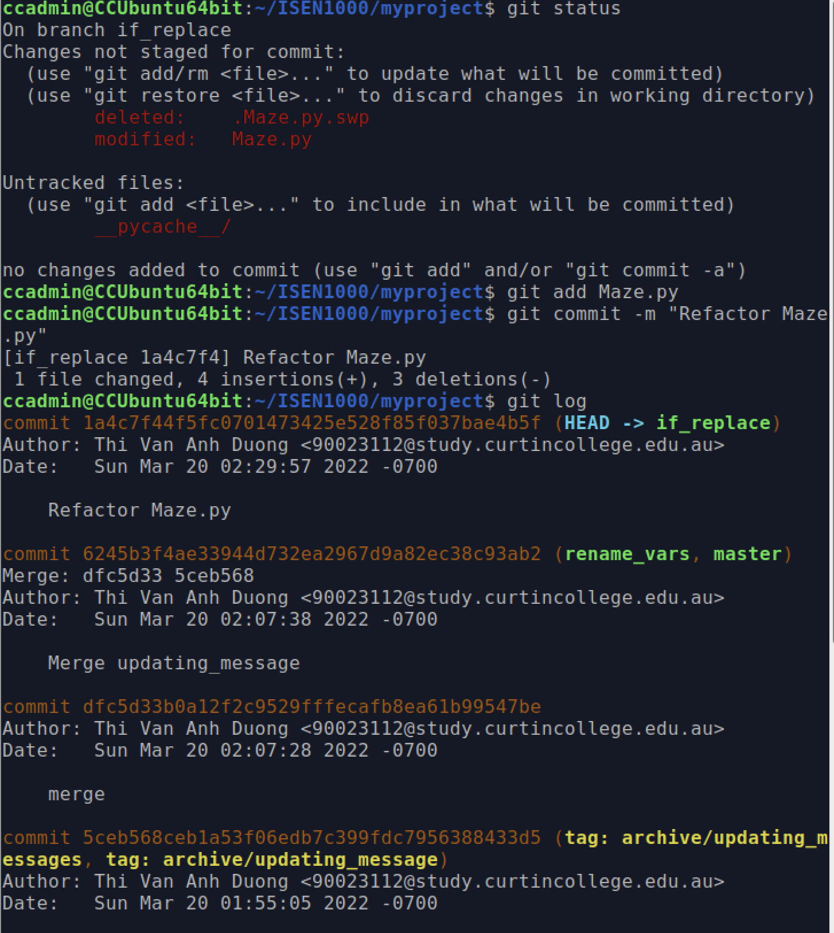

1. Switch to rename_vars and modify code

Use this command to rename the currentRow to row :%s/currentRow/row/gc

Use this command to rename the currentCol to col :%s/currentCol/col/gc

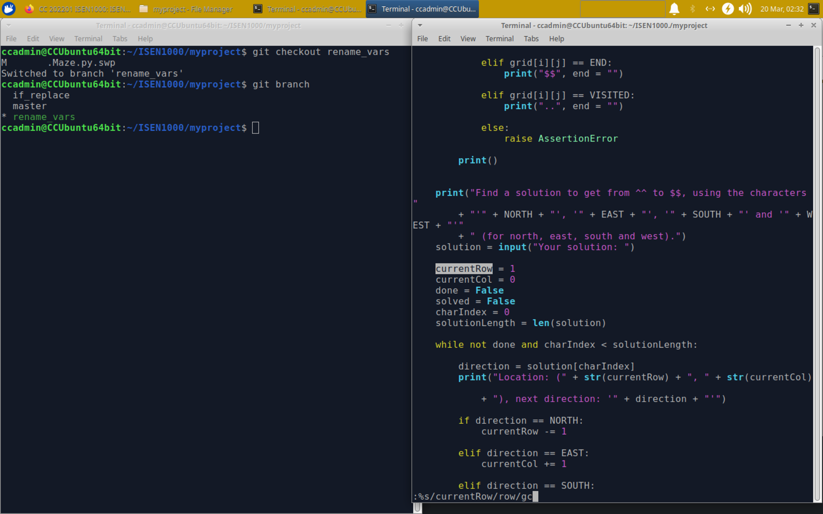



1. Switch back “master” and attempt to merge the changes

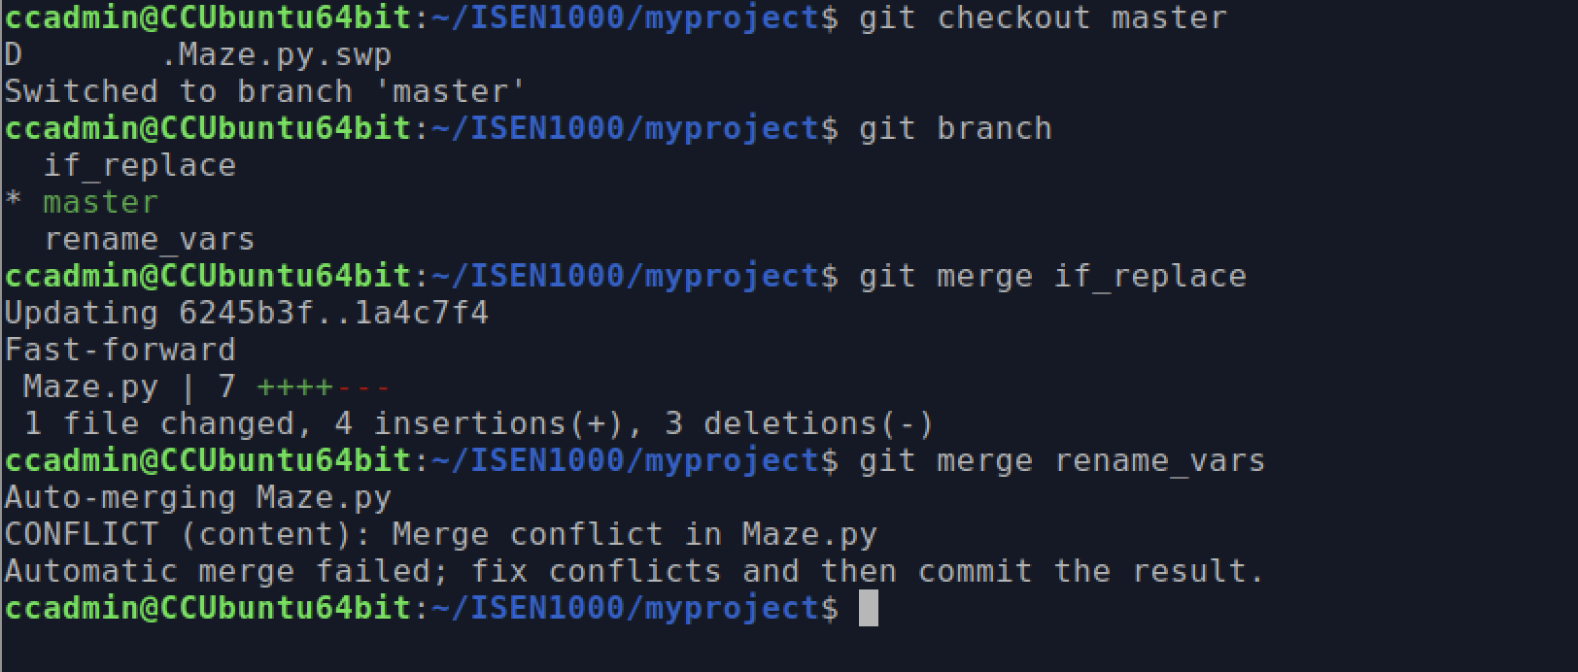

1. Run *git status*

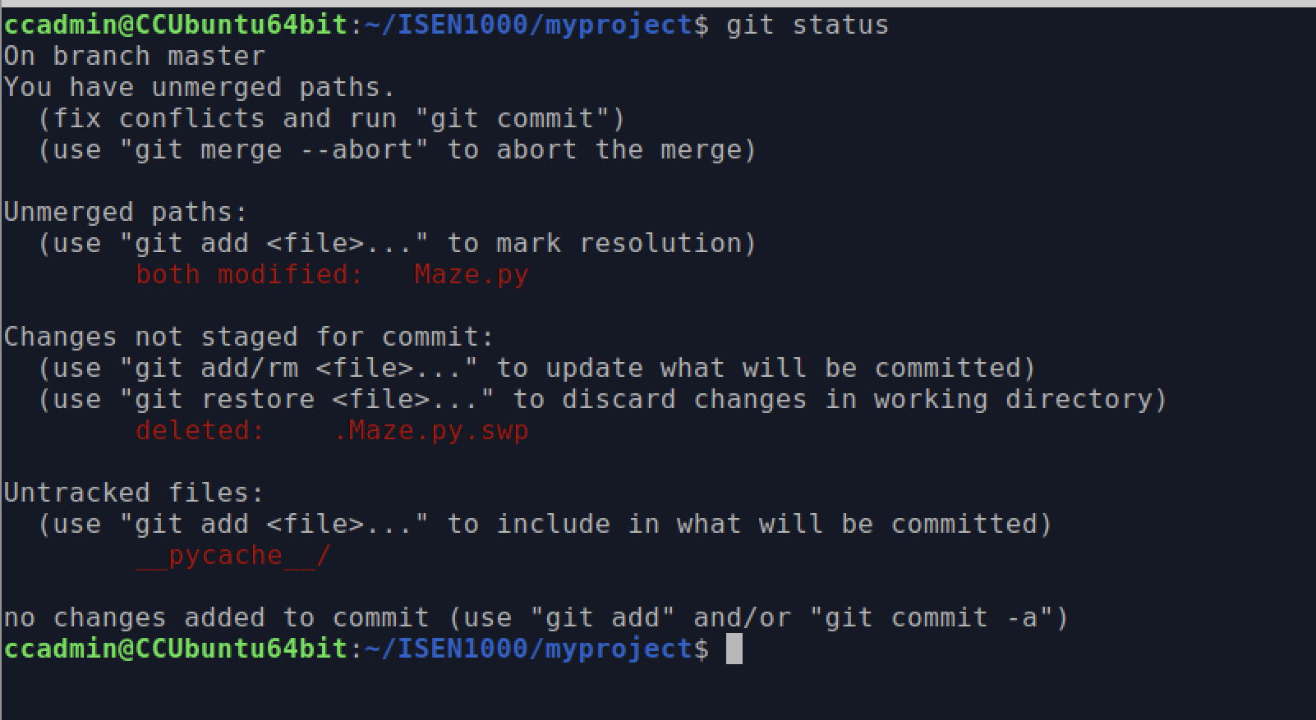

1. Open Maze.py
2. – Deletele code
3. – Replace code
4. -Delete code

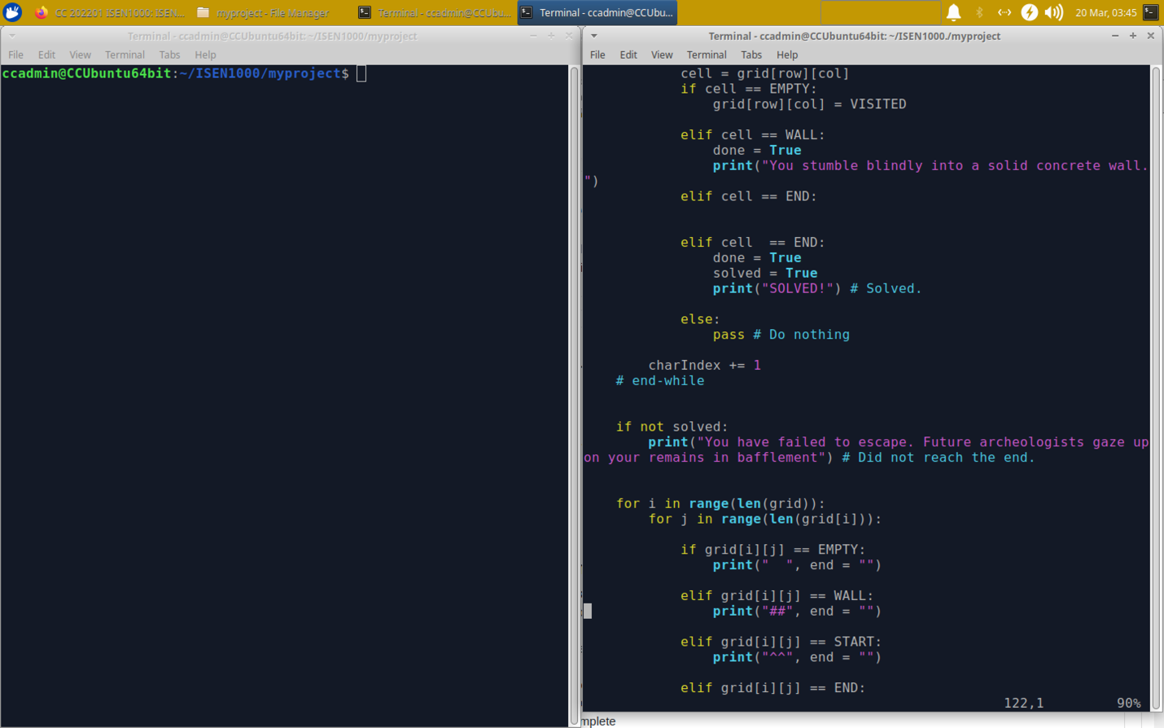

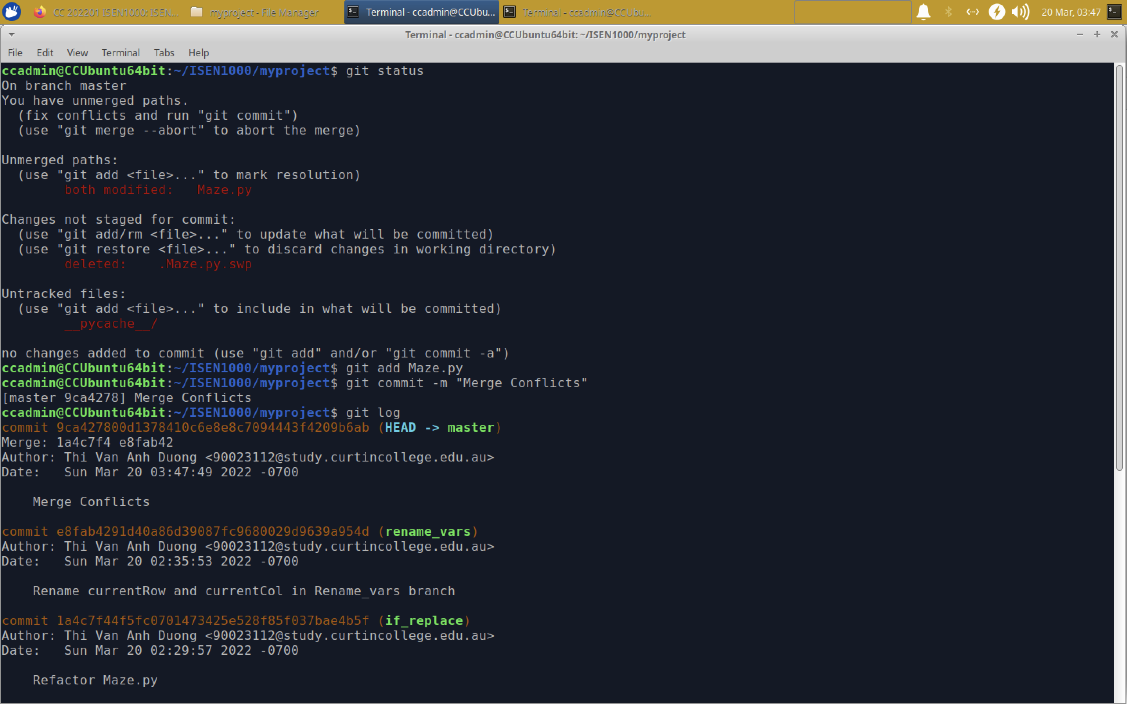

1. **Remotes**
2. Set up a “central” repository
3. Sign up for an account on git hub

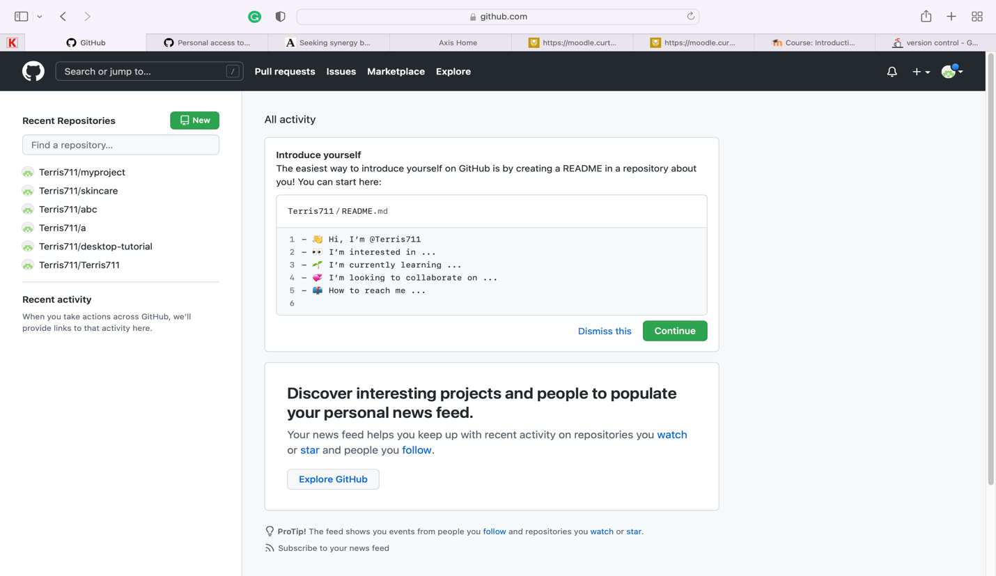

Create new repository (private):

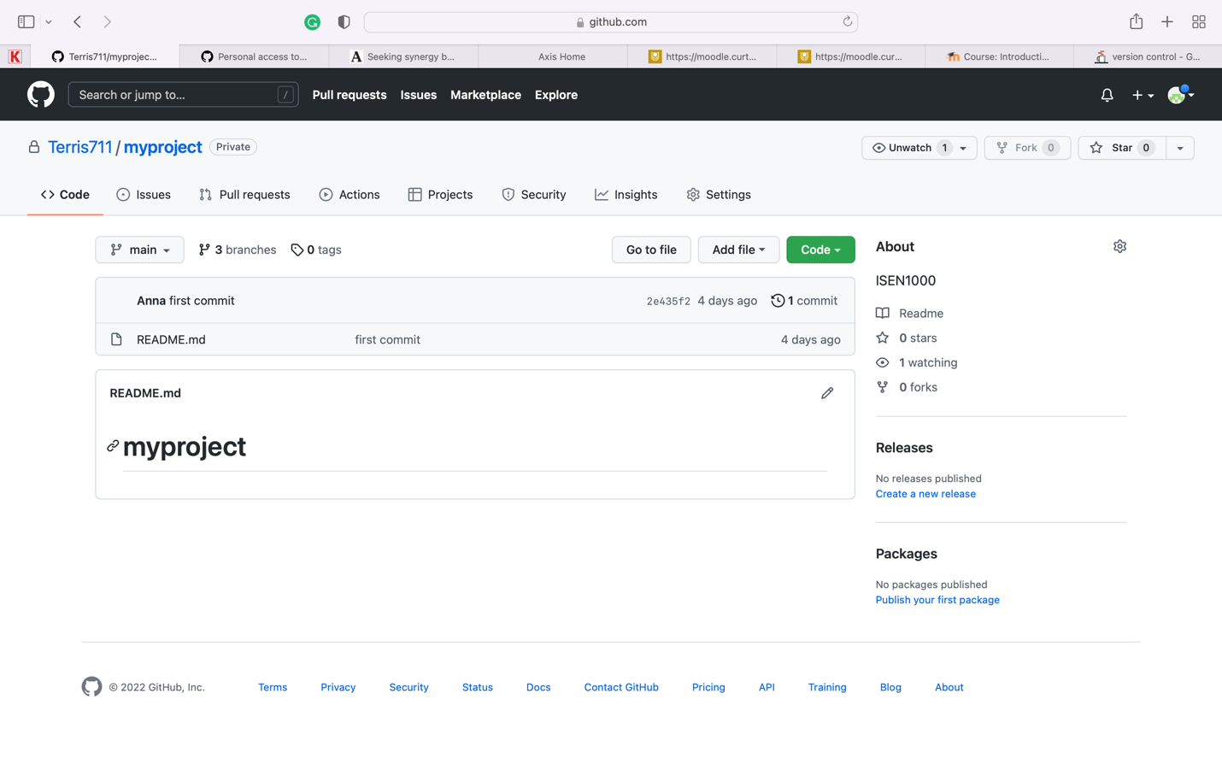

1. Tell local repo about the remote one

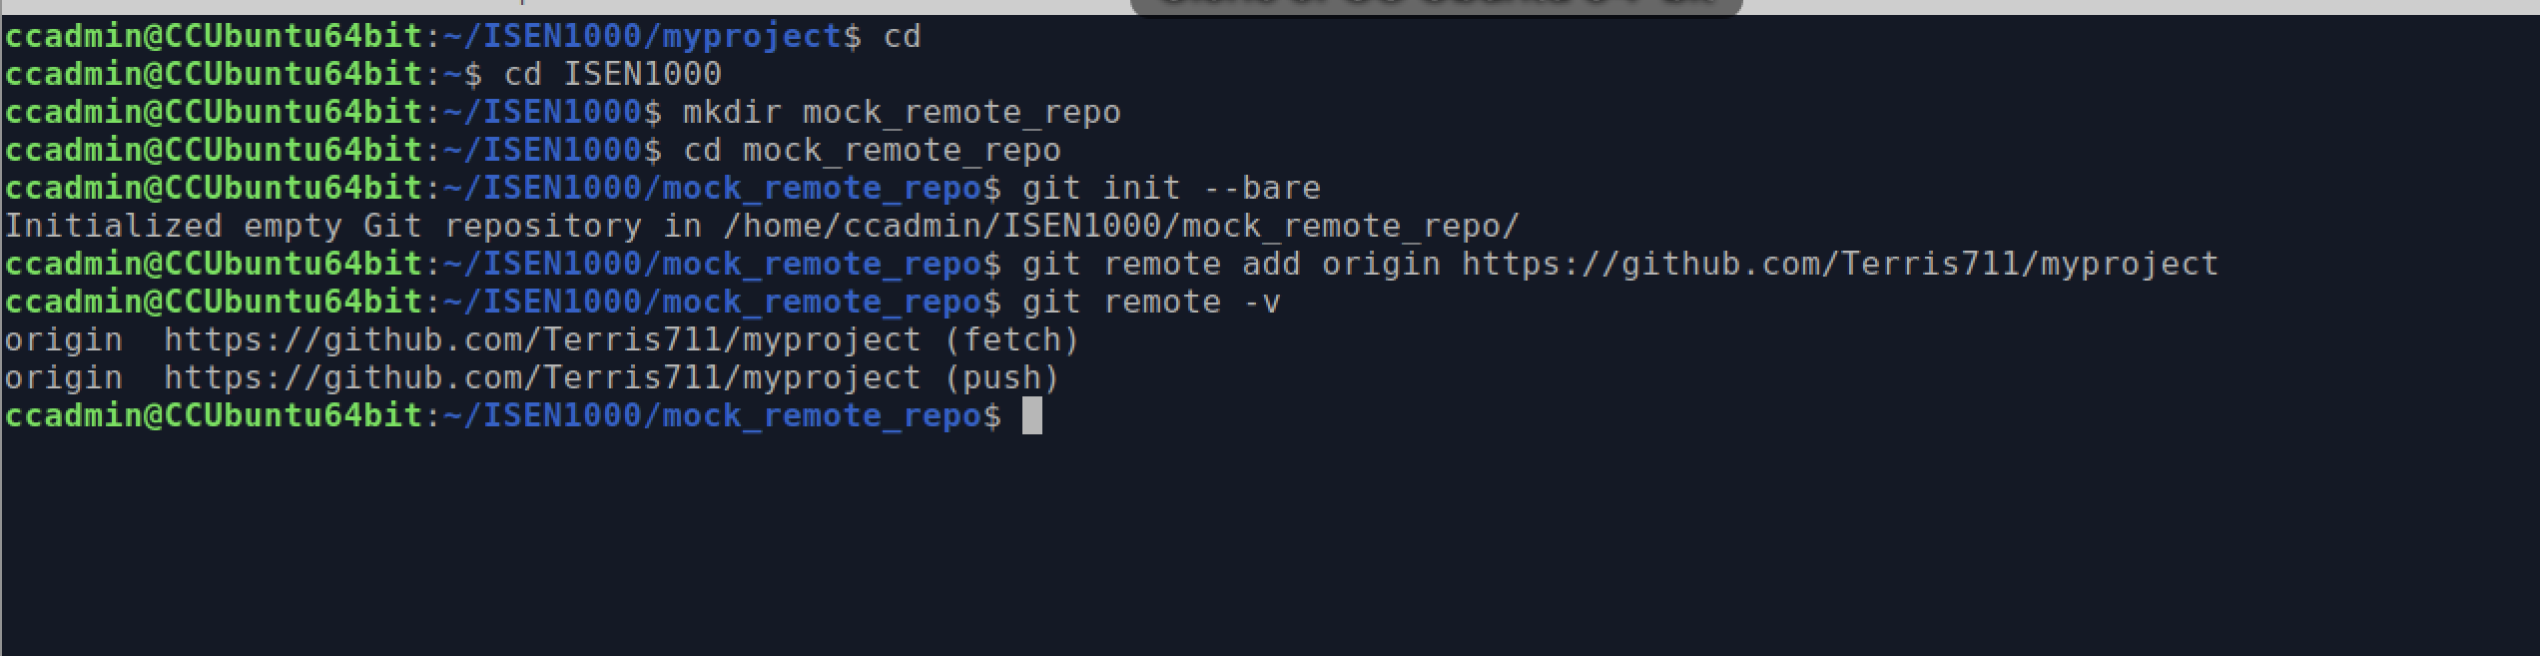

1. Try a push

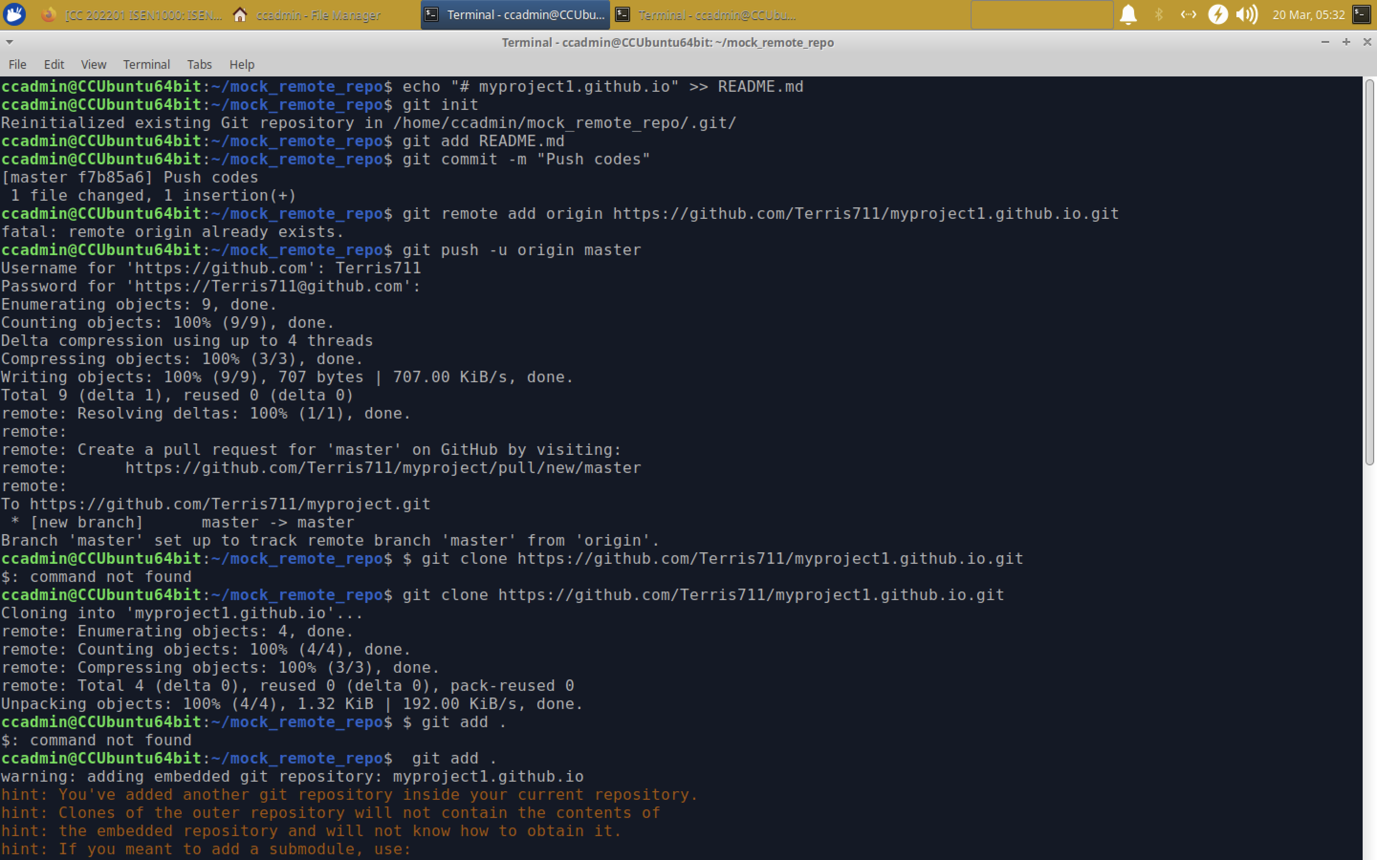

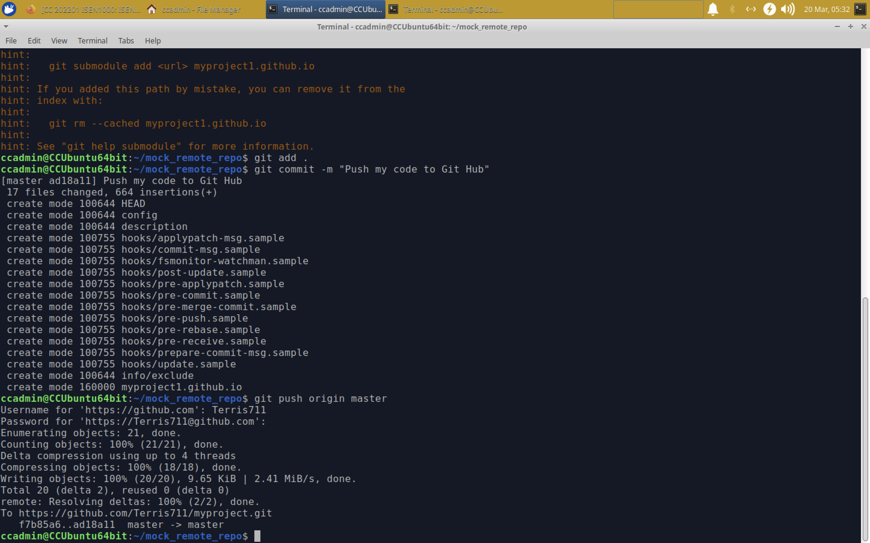

1. Check git hub web interface for pushing file

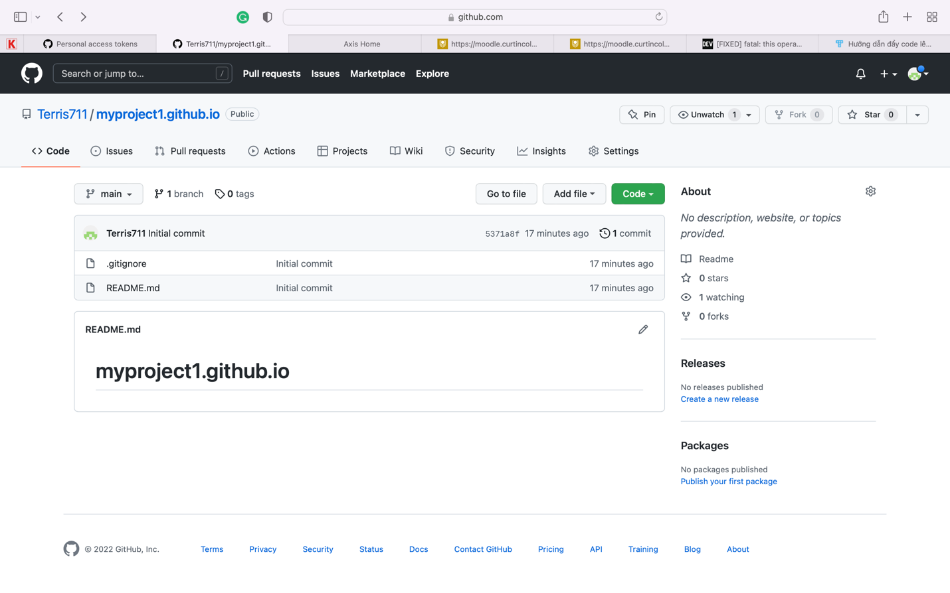

*Git log*

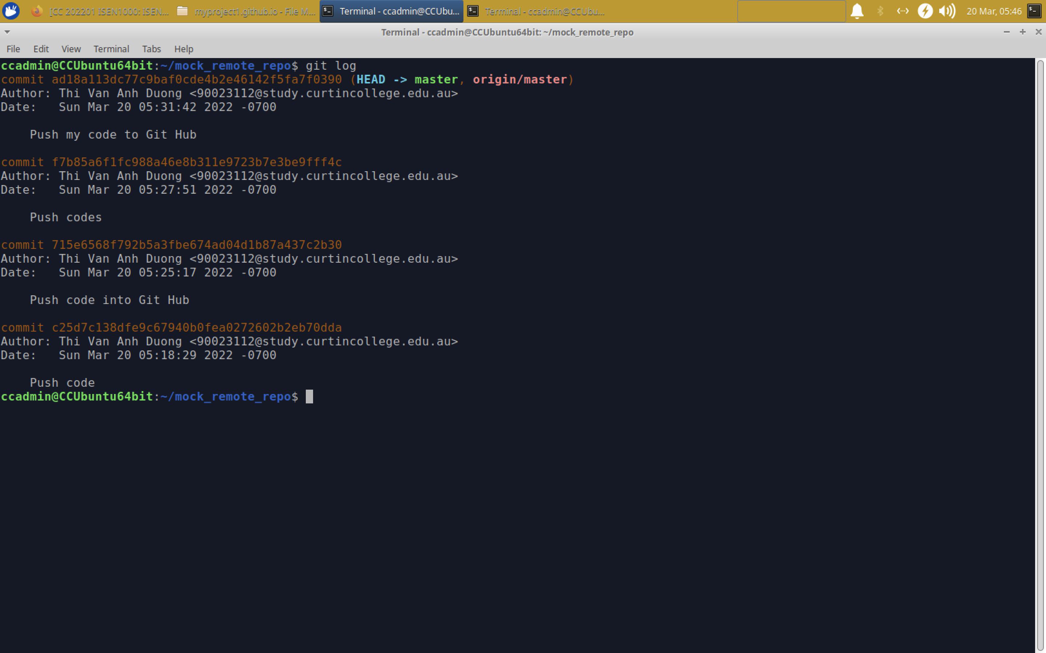

1. Simulate the second developer

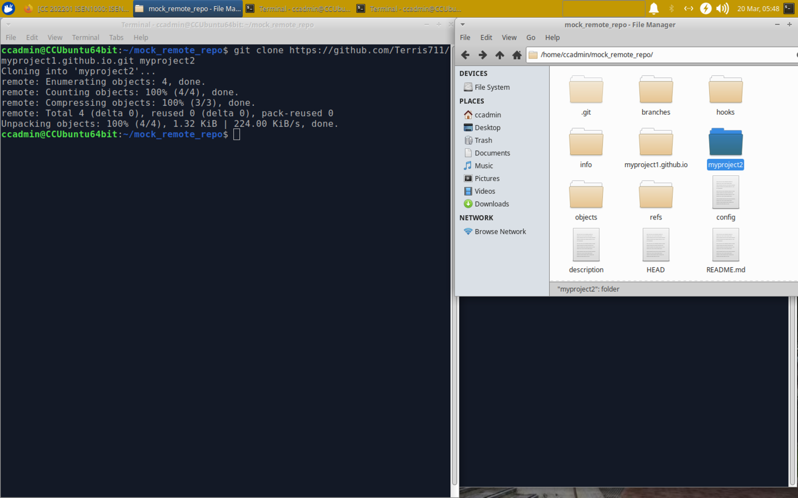

1. Make changes in “Developer 1”, Stage and commit then push my new branch to origin

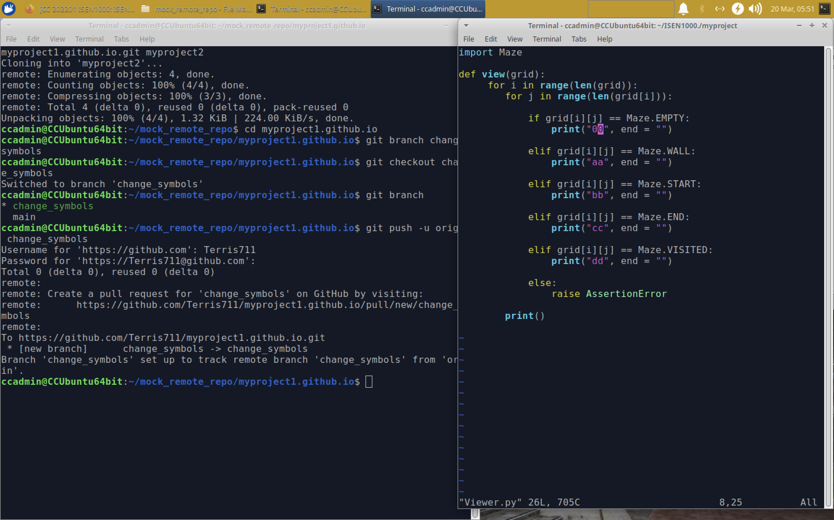

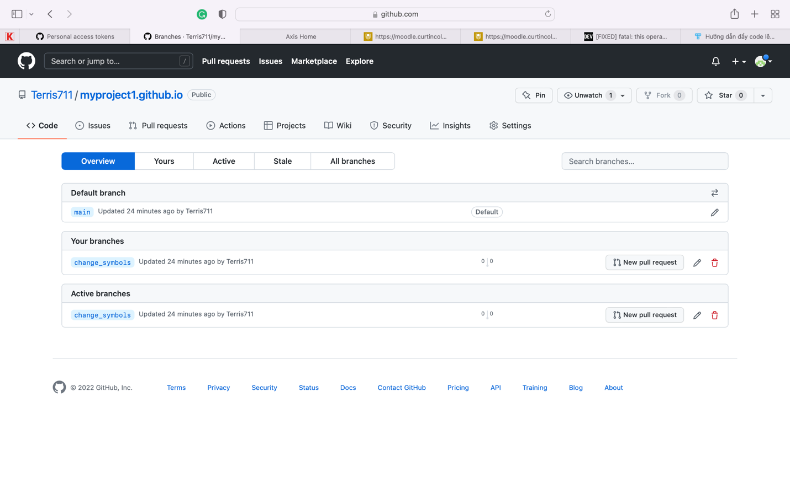

1. Go to the developer 2, Fetch the branch and switch to it

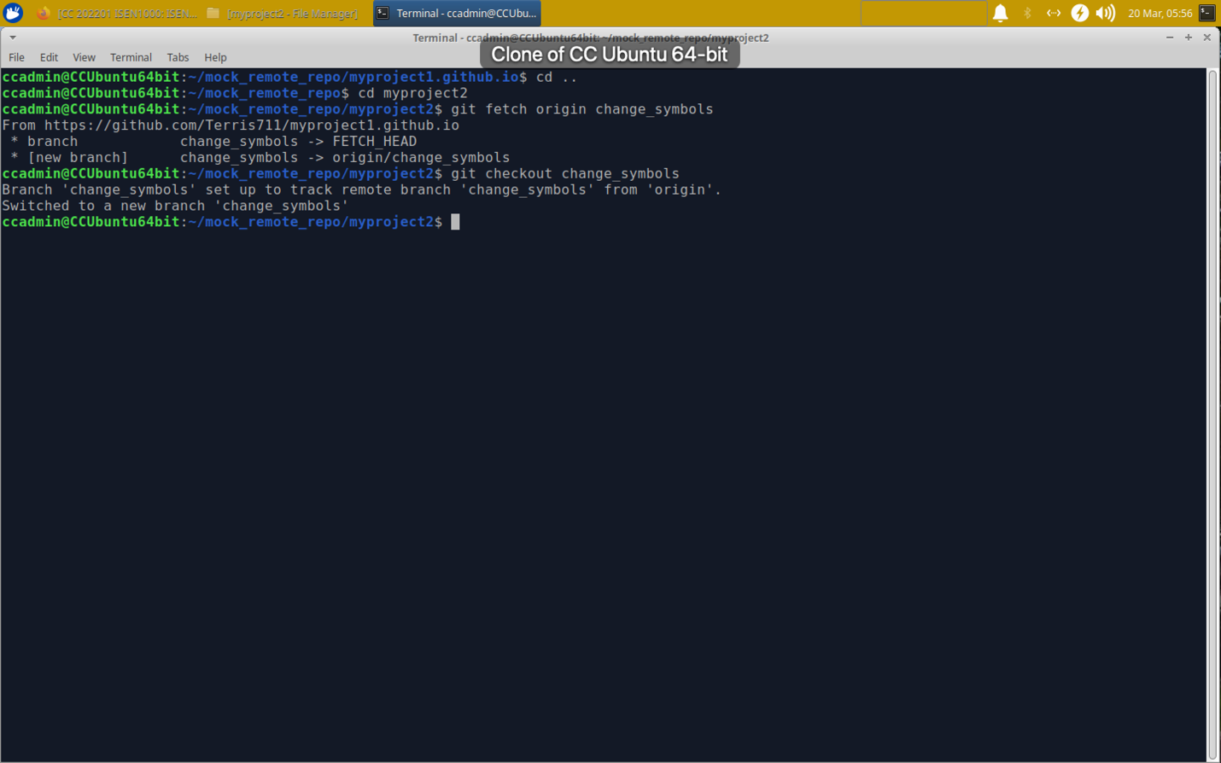

The Viewer.py is the same as I fixed with “Developer 1”

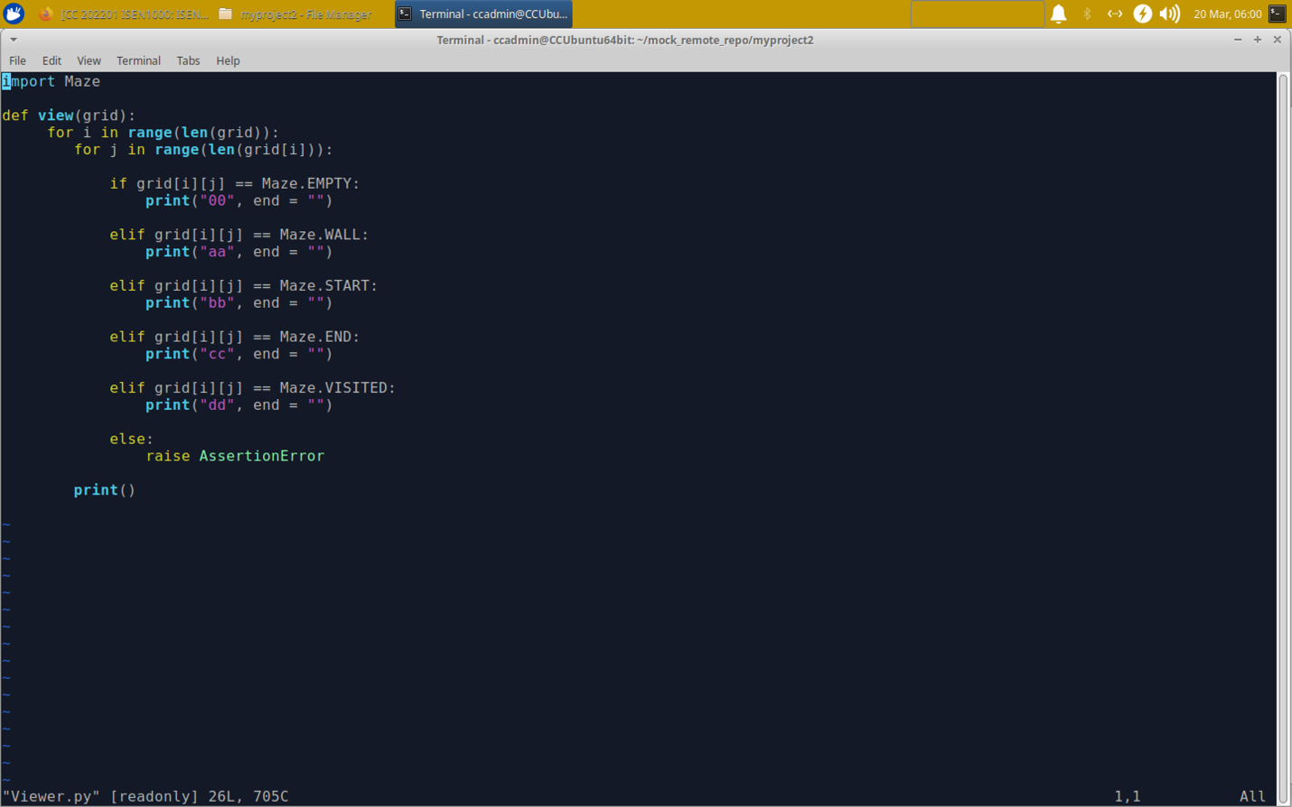

Go to “Developer 2” and merge the change to master.

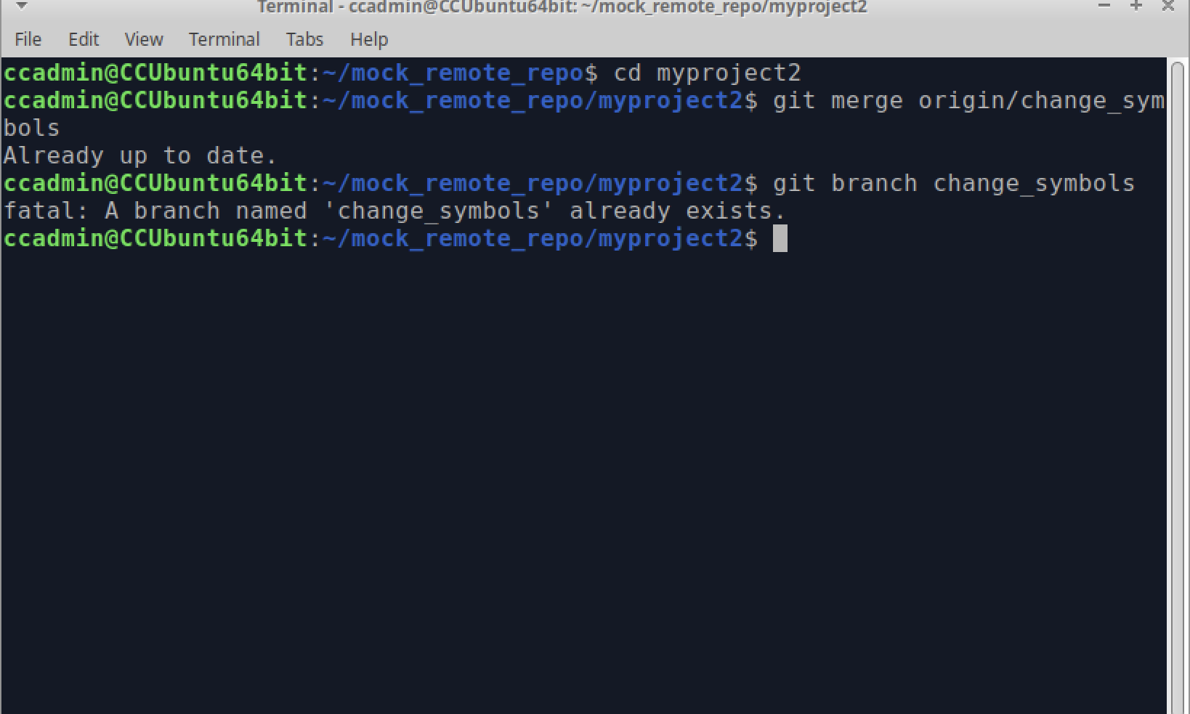

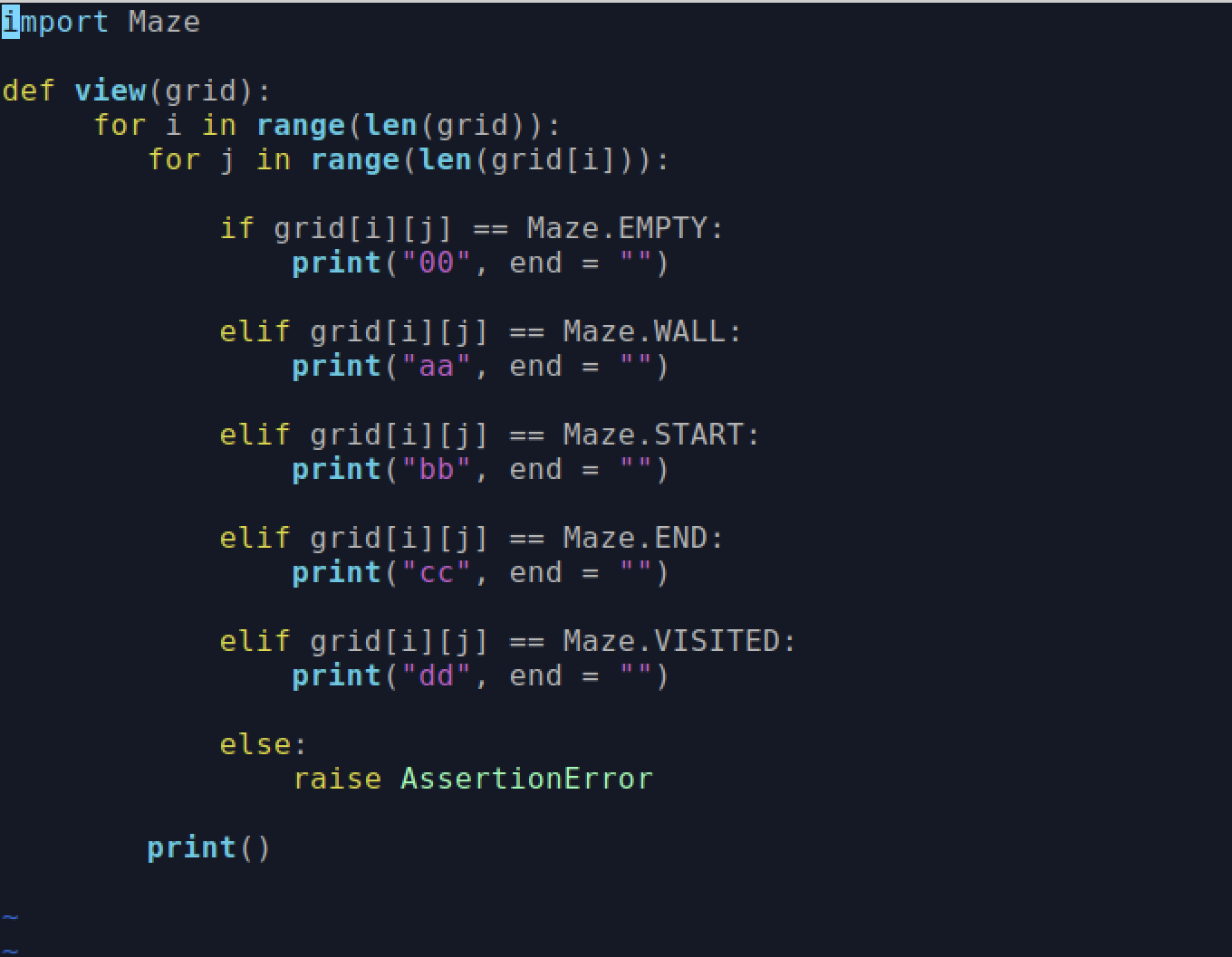

Put it back to origin

